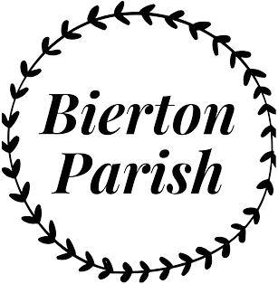
We have now reached Pre-Submission Consultation termed Regulation 14 stage of the neighbourhood planning process. This is your opportunity to view and comment on the draft Neighbourhood Plan before the document is submitted to Buckinghamshire Council for approval.

6 Week Consultation Period:
19th February 2024 - 31st March 2024
Open Public Event 24th Feb, 10am to 4pm, Jubilee Hall
The Neighbourhood Plan will be available to view on-line at www.bwbnplan.co.uk or for a hardcopy at the locations below:
- The Doghouse, Broughton Crossing
- St James Church, Bierton
- The Barn, Hulcott
- The Lounge India, Bierton
- The Jubilee Hall, Bierton
- The Bierton Sports Centre, Bierton
Feedback forms can be obtained from the locations identified above.
Please direct questions to nplan@biertonvillage.org.uk.
Requests for a hardcopy of the plan to be delivered can be made by ‘phone to 01296 422228

