History of Bierton pubs

At one point in time there were 7 pubs in Bierton and 2 in Broughton, just 3 remain. If you have any photos or additions/corrections to the following history, please email the Parish Council and we’ll update this information.

Contents
The Bell 4
The Crown Inn 6
The Doghouse (formerly the Prince of Wales) 8
The Eagle Brewery 10
The New Inn 11
The Plough 12
The Red Lion 14
The Seven Stars 16
The Star 18

5
9
8
7
4
6
3
2
1

1 = The Bell
2 = The Crown (site of)
3 = The Doghouse (formerly Prince of Wales)
4 = The Eagle Brewery (site of)
5 = The New Inn (site of)
6 = The Plough (site of)
7 = The Red Lion
8 = The Star (site of)
9 = The Seven Stars (site of)

4

2
7

2 = The Crown (site of)
4 – The Eagle Brewery (site of)
7 = The Red Lion

5?
8
6
1

1 = The Bell
5 = The New Inn (site of)
6 = The Plough (site of)
8 = The Star

3

3 = The Doghouse (formerly Prince of Wales)

9

9 = Seven Stars (site of)

The Bell is located at 191 Aylesbury Road.

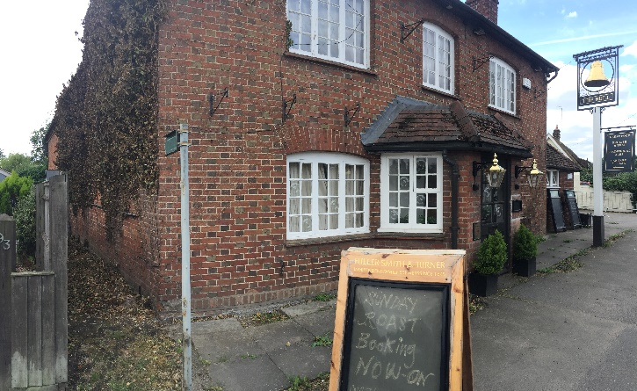
The 1841 census shows that the landlord and landlady were James and Sarah Monk. James was aged 60 and Sarah was 55. By 1847, James is listed as a Chairmaker and Beer Retailer.
In 1871, Charles Monk and his wife Mary have become the landlord and landlady. Charles is also a Chair Manufacturer, he is aged 41 and his wife is 40. Charles was born in Bierton, his wife in Southcott (possibly Southcourt). Their two eldest sons Henry (18) and George (15) live with them at the pub and are both employed as Chair Makers. Also living with the family are their younger children Frederick (9), Walter (8), William (6), Mary (4) and Rose (2). All the children were born in Bierton.
By 1877, Richard Honour has become the Landlord. In the 1881 census we see Richard living at the pub, he’s a general labourer and publican and is aged 60. He lives with his wife Fanny (55), their daughter Kezia who is aged 18 and a dressmaker. On the day of the census, there are two visitors staying at the Bell, Minie Eaglestone, aged 3 from Hammersmith and Sarah Jane Bray aged 21 and a domestic servant from Walworth. Richard Honour stays at the pub for some years, appearing in the 1891 census, his wife is now more grandly named Frances, rather than Fanny, he is now 70 years old and his wife is 65.
By 1899, Joseph Thorne is the landlord (possibly a relative of the World War 1 Thornes). He is aged 62 and hails from Hulcott. He is married to Kezia who is aged 38 and from Bierton. Kezia could be Richard Honours daughter (see paragraph above. The 1901 census shows Joseph Thorne (62), Kezia Thorne (38), Daisy (11), Lily (8), Ivy (3) and Charles (1 month) all living at the Bell. The 1911 census shows Joseph (73), Kezia (48), Ivy (13), Charles (10) and Eric (6). Two daughters are crossed out on the census, presumably they are living elsewhere, Daisy Harriett (21) and Lily (18). Joseph continues to appear in the Kellys Directory until 1928 when Charles W Thorne has taken over as Landlord of the pub. Presumably this is Charles who was born in 1901.
In 1931, we see Henry G Honour as the landlord and his name continues in the 1935 Kellys directory. Henry Honour could be a relative of the Honour family who ran the pub in the mid 1800’s.
We’ve then got a gap in the history of the pub, until Mac & Margaret Taylor who were landlords during 1970s/80s. Dave & Vee White were landlords in 90s. The current licensee is Charan Chusith.
The present Bell pub serves excellent Thai and English food and you can also order a takeaway. https://www.bellbierton.co.uk/

The Crown Inn
The photo below was taken in 1904 and shows the Crown Inn on the right at what was 111 Aylesbury Road, which is on the corner of Parsons Lane, nearly opposite the Red Lion pub. The building has since been demolished.

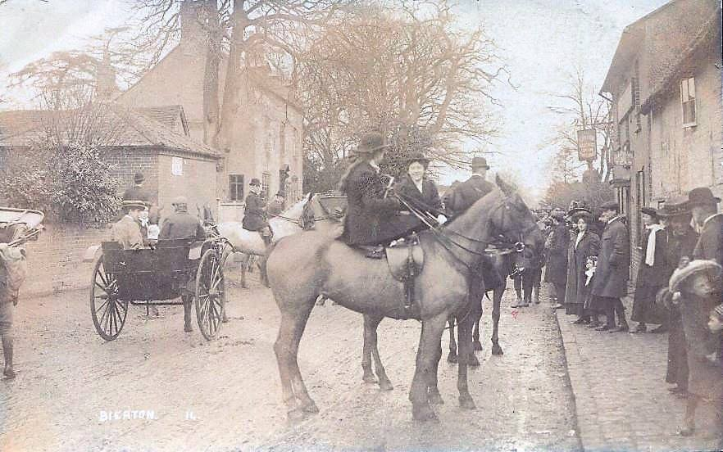

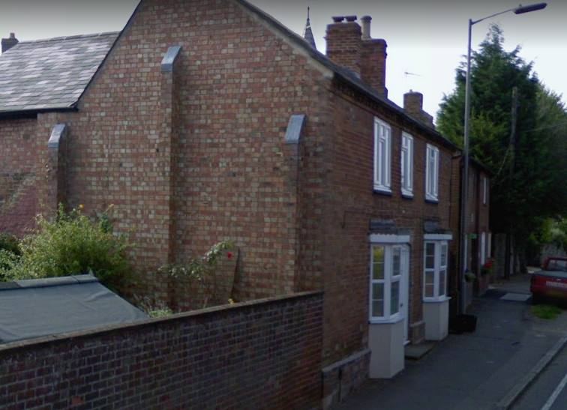
This photo shows the houses which would have been neighbours to the Crown. The garden wall with the shed next to it is the site of the pub.

The 1841 census shows that the landlord is Jacob White who is listed as an Inn Keeper, he is 46 years old. He lives with his wife Elizabeth White (43) and their children Jacob (21), Jane (19), Elizabeth (16), Ann (14), John (12), James (10) and Henry (4). 10 years later, the 1851 census shows Jacob (57), Elizabeth (54), Ann (24 a Plaiter), Henry (14 an Agricultural Labourer), Harry (6 Grandson). In 1854 Jacob is still shown as the landlord and is now cited as Beer Retailer and Parish Clerk in Kellys Directory.
By 1861, the Price family are running the Crown Inn. John Price is aged 47 and is shown as a Beer House Keeper, he was born in Bierton as was his wife Mary (44). Living with them is Joseph Deering a boarder who is a labourer aged 88.
John Price died between 1869-1871 as the 1871 census shows that his widow, Mary is now the Beer House Keeper. She is living at the Crown with her grandson, George A Price (5) who was born in Camden Town. Lizzy Grisree is boarding at the Crown and is a 14-year-old Straw Plaiter from Kensworth in Bedfordshire.
Ten years on, the 1881 census shows Mary Ann Price is aged 64 and has a domestic servant helping her, the servant is Nelle Wallis who is aged 12 and from Broughton. Mary continues to run the pub until 1883-1887 at which point George Price becomes landlord. George may be her Grandson (see paragraph above). George appears in the Kellys directory of 1887 as the proprietor of the Crown.
By 1891, Richard Rolfe is the Beer Retailer who runs the Crown. The 1891 census shows he is aged 51 and from Aston Clinton. His wife is Elizabeth (46) also from Aston Clinton. They have a boarder staying with them called William Rollet (25). The 1901 census shows Richard (62) and Elizabeth (57). In the 1903 Kellys directory, Elizabeth is shown as the Beer Retailer.
There’s no information we can find as to when the pub closed and was demolished. Can anyone help?

The Doghouse (formerly the Prince of Wales & formerly The Crossing)
In the 1840s, a branch railway was constructed linking Aylesbury to the Midlands, this crossed the road linking Broughton with Bierton. A public house and signalmen’s cottages were constructed at the level crossing and the area became known as Broughton Crossing.

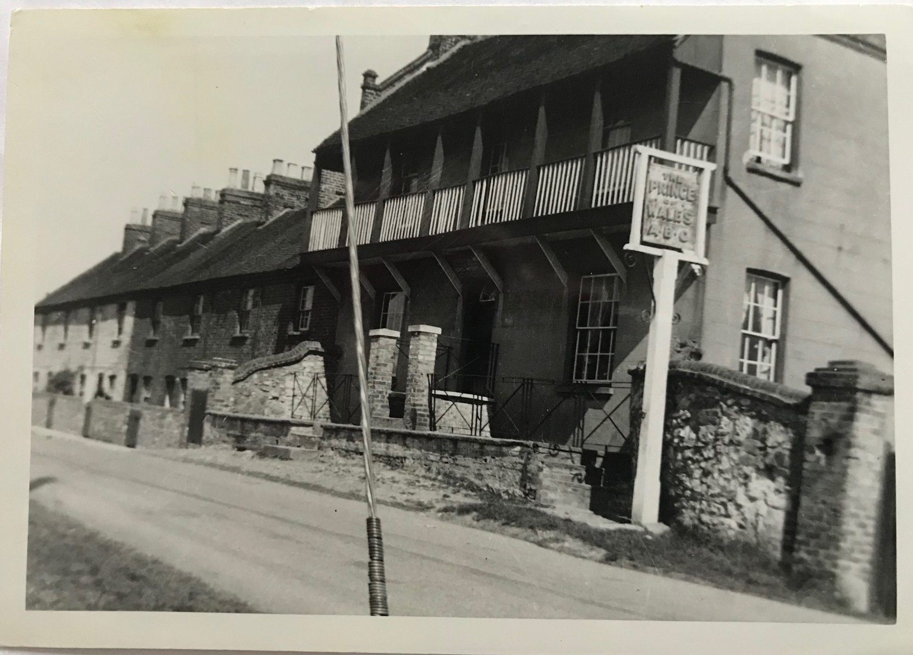
The pub had a balcony running along the front at one point in time, which has since been removed. We hope that it’s the wire that’s leaning in this photo and not the buildings.

The 1871 census shows Jesse Wootton (47) as a Beer Retailer of the pub, together with his wife Martha (40). They live at the pub with their niece, Sarah Ann Smorh, aged 7.
The 1881 census shows that Jesse and Martha are still running the pub, but Jesse is now a farm labourer and Martha is Landlady of Beer house.
At some point between 1883 and 1887 the pub changes hands and John Day becomes the Beer Retailer and Carrier at the pub.
The 1891 census shows George & Mary Ann White running the Prince of Wales pub. They live there with their children Annie (22), George W (18), Algernon (12), Nellie Ada (10), Theodore (7) and Florance S (4). Sadly, Algernon will go on to die in action in WW1 and is remembered on the war memorial by St James Church.

The 1901 census shows George & Mary Ann White are still running the pub with Algernon (23 Builders Labourer), Theodore (17 Farm Labourer) and Florance (14 At home Domestic). George continues to be the Landord until the late 1910’s/early 1920’s.
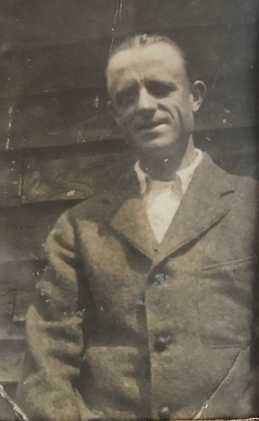
The First World war, had a big impact on the White family. Two of the Landlords sons, Theodore and Algernon saw action. Theodore Charles White (pictured right) served in World War I as a Lance Corporal in the 1st Buckinghamshire Battalion. Theodore saw action in Africa and India after completing his training in Wolverton. Thankfully, he returned home.

Sadly, his brother, Algernon, didn’t return. Before the war, Algernon was a Dairyman, employed in Burcott by Freddy Chappin. He didn’t marry or have children. He enlisted as Gunner White - 144909 of the 12th siege battery of the Royal Garrison Artillery on 11th December 1915 at the age of c37. He was in the Reserve and didn’t serve active duty until he went to France on 9th March 1917. Sadly, he died just over a year later on 19th April 1918 after he was shot in the lungs, while on active duty. He was awarded two medals, the Victory Medal and a campaign medal. He is buried: Rue-Petillon Military Cemetery, Fleurbaix, Pas de Calais, France. His relatives still live in Bierton

Theodore married after the war and he and his wife, Mabel, took over the running of the Prince of Wales pub in Broughton when his parents died. Theodore remained as the landlord until at least 1935.

During World War 2, the Prince of Wales pub, housed at least 4 refugees. Mr and Mrs Mary Abrahams and their toddler son, Brian were Jewish refugees living in the pub. Mrs Cooper from Jamaica Road in the East End of London also lived there, she was Catholic. The pub owners were Church of England. Apparently, there were never any issues or disagreements.
Just down the road at 11 Broughton Crossing, lived Mrs Cooper’s daughter and son in law, who had also moved to get away from the London bombings.
The Prince of Wales pub was also a regular haunt for another London couple, who used to visit, the husband is remembered as warming his back by the fire and physically shaking whenever the air-raid siren sounded.
At some point, probably in the early 2000’s the pub changed name to The Crossing, presumably to reflect the fact that there used to be a railway crossing nearby, hence why the area is often called Broughton Crossing.

The pub changed name again around 2007 when it became the Dog House Inn – as a refuge to those who had an argument with their other halves and were ‘in the dog house’. The current licensees are Gary and Teri Moult who have run the pub for at least the last 10 years. The present-day pub serves an excellent Sunday Roast with Yorkshire puddings which have to be seen to be believed. http://www.doghouseinn.co.uk/

The Eagle Brewery

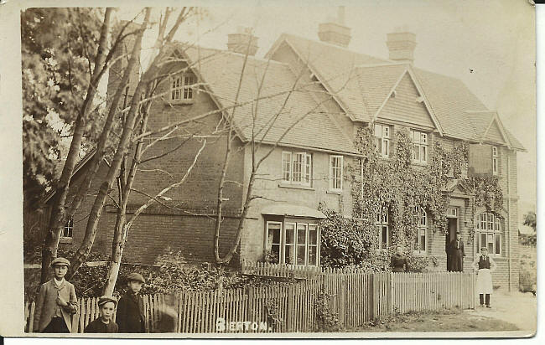
The Eagle was situated next to what is now Jubilee Hall.

In the 1847 Post Office Directory, we see George Rawlinson in residence as the Beer Retailer. By 1854 he describes himself as Brewer and Beer Retailer. In 1864 Sophia Rawlinson is shown in the Kellys directory as Beer Retailer.

By 1869, Sophia’s son, James Rawlinson is shown as Brewer & Beer Retailer in the Post Office directory.

The 1871 census shows Sophia is a widow aged 63 and is living with her son James (42) and her daughter Rose (18 – Domestic). Both James and Rose were born in Bierton.

By 1881 there has been a change in ownership and David Lacy, a Groom aged 27 from Chesham is living in the pub, with his wife Elizabeth (25 from Bierton) and their daughter, Anne (2 – also from Bierton).

By 1877 the Kellys directory shows that James Rawlinson is back in charge at the Eagle. He is described as Brewer. In the 1881 census, Sophia Rawlinson-Ducker (did she re-marry to a Mr Ducker?) is shown as a widow, aged 72 and Bird Dealer. She lives with her son, James, aged 32 and a Brewer. James continues to appear in the Kellys directories of 1887 and 1891 as Brewer. The 1891 census shows James (42), Emma Clarke (30) and George Higgins (55 year old Farm Labourer, widower) living at the Eagle.

There is little to be found as to the history of the pub from 1891 to the 1960s.

The pub was still in use in 1970, when a local remembers living opposite and going to the pub where the beer was kept out in the back in barrels. There weren’t any spirits as it was a beer house and did very good bitter.

We’re not sure when it closed, but the doors of the pub are still there are and you can see the ‘Eagle’ written on the glass of the doors today.

The New Inn

Our best guess is that the New Inn was located opposite Barnett Way, but there is little information as to its exact location.

The 1838 poll book and electoral register shows Richard Roberts living in a free hold house – this could be the New Inn or it could be a house he owned.

The 1847 Post Office Directory shows that the landlord of the New Inn was Richard Roberts, who also worked as a Blacksmith. The 1851 census shows Richard is aged 60 and is living with Hanna (nee Inns) his wife (45 from Aston Abbots), Elizabeth (21 Straw Bonnet Maker), William (18 – Blacksmith), Sarah (14), Hannah (11), Susan (8), Emma (6) and Richard (3). All the children and Richard were born in Bierton. On the day of the census, William Parsons was visiting, he was an 18 year old Baker from Aston Abbots.

The 1861 census shows Richard (69 – Publican and Blacksmith), Hannah (55), Emma (16), Richard (14). Richard Snr dies between 1861 and 1863 as his son William is listed as the Publican and Blacksmith. By 1864 Hannah is shown as the Publican and Blacksmith, although I doubt she did any of the smithying.

In the 1871 census, Hannah is shown as being a 64 year old widow and employing 2 men, her grandsons John (14 – Labourer) and Thomas (12 – Labourer).

By 1877, William Roberts, son of Richard, is listed as Publican and Blacksmith in the Duttons Directory. The census in 1881 shows, William (48), Ann his wife (54), Thomas his son, (22 – Carpenter), Elizabeth his daughter (20 – Dressmaker), Harry (17 – Carpenter), Annie (15 – Dressmaker) and a Lodger called George Heel who is a 16 year old Horse Keeper born in Bierton.
By 1891, William no longer appears to be running the pub as the census shows William is listed as Dealer in Horses, he’s aged 58. Anne is 64. Living with them are Thomas 32 who is a Carpenter, Elizabeth 30 who is a Dressmaker. Harry aged 27 also a Carpenter, Annie aged 35 also a Dressmaker.
In the 1901 census, William is a Master Blacksmith, aged 68. Ann is aged 73. Elizabeth is still living with them aged 40 a Dressmaker. Annie is aged 45 and is still a Dressmaker.

We’re not sure when the pub closed, it could have been c1891 onwards. Maybe William decided there was more money in horses and blacksmiths work, than beer?

The Plough

The plough was located on the right-hand side of the village as you head towards Rowsham, nearby what is now Plough End.

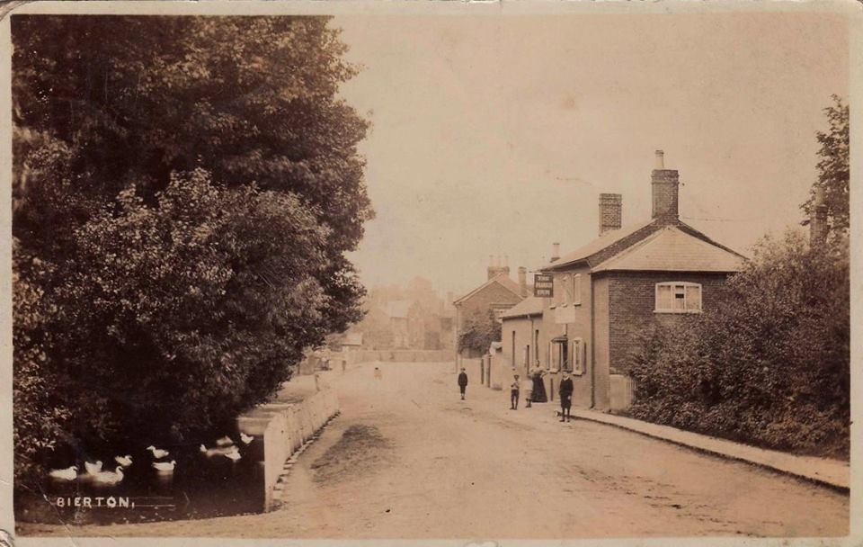

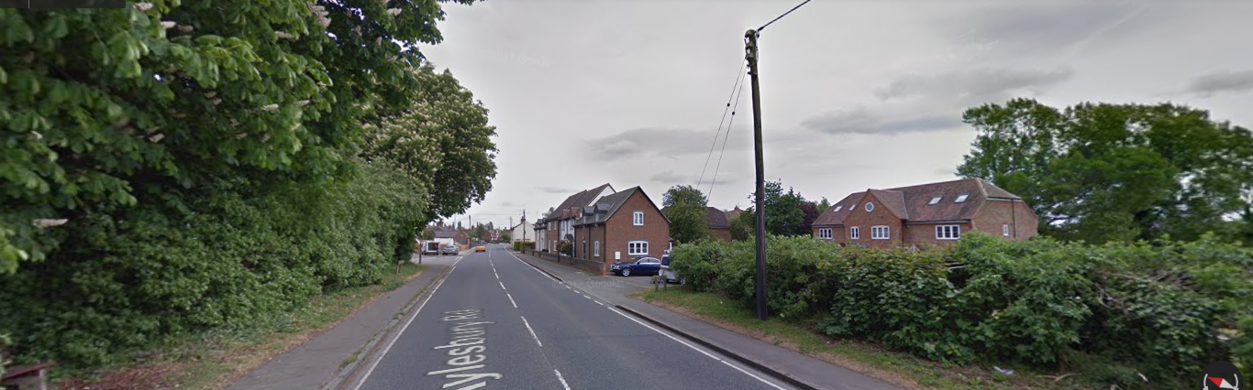

Top photo shows The Plough c1908 and is kindly provided by Andrew Cooke. You can see the old village pond, complete with ducks on the left. This was used to provide water for horses and to drive carts through. The photo below shows the same view in 2017.

The 1841 census shows Thomas Elliott is the 33-year-old Inn Keeper at the Plough. He is living with his wife Mary (35) and their daughter, Elizabeth (11) and a female servant called Patience Harding (13)

By 1847 the Post Office Directory shows that Joseph Elliott is running the pub and is also a Butcher. The 1851 census shows that Joseph is aged 29 and is living with his wife, Sarah R Elliott (27) and their daughter, Sarah (3 months). Also in the house are William Atkins an 18 year old Houseboy and Mary Griffin an 18 year old Housemaid. Joseph is still the landlord in 1854 when he appears in the Kellys directory.

By 1861 Frederick Spittle is the Publican and ‘House Breaker’ (demolisher). Frederick is aged 28 and was born in Buckland. Also living at the pub is his wife Mary Anne (25) and their son Thomas W Spittle aged 1. Thomas was born in Bicester. At the same address is Susanna East a visitor and widow aged 60 from Aston Clinton and Joseph Carsons a boarder and Tailor aged 20 from Trowbridge. There are two servants living in the house Elizabeth Gilbert, aged 15 a House Servant from Great Kimble and Frederic Thorne a Stable boy aged 17 from Hulcott. Frederick Spittle continues to be the Publican until sometime between 1864 and 1869 when Robert Young takes over.

By 1877 Robert Young is the Publican listed in the Kellys directory. The 1871 census shows Robert is a 56 year old Inn Keeper who was born in Newton Longville. He lives with his wife Mary (57 from Weedon) and their children, Louisa (26 Dressmaker from Adstock), William (22 – Butcher born in Bierton), James (16 – born in Bierton) and Mary Ann (13 born in Bierton). This may be the same Robert Young who was Landlord at the Red Lion in the mid 1800’s.

10 years later in the 1881 census Robert is aged 63, Mary is 67 and living with them are, Louisa (36 – Housemaid), William (31 – Butcher), James (24 – Butcher) and Mary Ann (23 – Dressmaker). The family stay as publicans until at least the 1891 census which shows Robert is a widower aged 74, his daughter, Louisa is 46, his son James is 35, Mary A is 32. A visitor is staying with them on census day his name is John Tarpin a widower from Weedon aged 66.

By 1895, George Miles appears in the trade directories as Publican and Market Gardener. The 1901 census shows George (44 from Stone), Mary A Miles his wife (43 – from Bierton), Louisa Young (sister in law to George aged 58), James Young (brother in law to George aged 46 from Bierton), George Miles Junior (4 – born in Bierton). Also staying are Kate Ireland a visitor aged 32 from Cholesbury and Joseph Turpin, Uncle to George Miles, who is aged 90, a widower and retired valet who was born in Weedon. It’s possible that the Miles family were related to the actor Sir Bernard Miles (In Which We Serve 1942 etc) who is reported to have lived in the village at some stage of his live.

The 1911 census shows George is aged 54 and describes himself as a Licensed Victualler. His wife Mary A is 53, Son George Junior (13), Louisa (sister in law – 66) and James (brother in law (56 – Butcher).

We have no information as to when the Plough closed.

The Red Lion

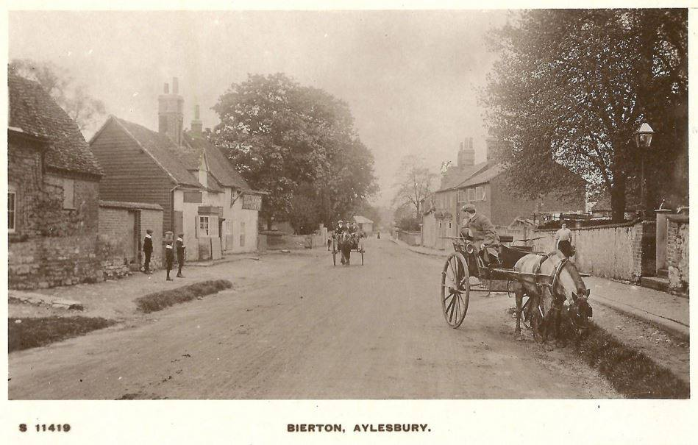

Photo kindly provided by Andrew Cooke shows the Red Lion pub on the left.

Is located at 68 Aylesbury Road and is a 16th Century Public house situated opposite the Church of St James the Great in the Buckinghamshire village of Bierton. The Red Lion was significant during the English Civil War when it was host to many Royalist Officers, including it is rumoured King Charles 1st.

The 1851 census shows Robert Young (32) is the Publican of the Red Lion. He is married to Mary (36 from Wendover) and they have 2 daughters and a son. Louisa (6 born in Adstock), Eliza (4 - born in Adstock) and William R (2 – born in Bierton). Also living with them is William Norwood a Lodger, who is a 30 year old Labourer who was born in Bierton.

10 years later in 1861 the family are still at the Red Lion. Robert is 42, Mary is 47, Louisa is 16William is 12. They have 3 more children, John (10), James (6) and Mary Ann (3). In the 1861 Duttons Directory, Robert is listed as Publican and Pig Dealer. Is this the same Robert Young who became the Landlord of the Plough?

By 1869, John Reading is listed in the Post Office directory as the Publican. The census of 1871 shows John & Sarah Reading, both aged 40 and both from Bierton as living in the pub. The 1881 census shows John & Sarah are now aged 50 and have a General Servant, called Mary A Stevens who is aged 19 and from Hulcott living with them.

The 1891 census shows John aged 60. Sarah has died. John has remarried to Mary A Reading (did he marry the servant girl??), who is aged 30 from Hulcott. They have a daughter called Emma who is aged 3.

By 1895, John is described as Publican and Cattle Dealer in the Kellys Directory. He continues to appear in trade directories until 1903.
By 1911, John Whiting is the Publican. The 1911 census shows he is aged 33 and from Amberton. He is married to Annie (31 – London) and they have 4 sons, John (10 – born in Manchester), Leslie (6 – born in Bournemouth), Arthurt (5 – born in Bournemouth) and George (7 months born in Bournemouth). Also living with them is an Uncle, called William Simmons aged 45 from London.
By 1915, John Taylor is listed as the Publican.

In 1924, Albert Edward Menday is listed as Publican and he continues at the pub until at least 1935.

More recent licensees include: Tich & Heather Bishop, Derek & Carole French, Mary ?, Sue & Hannah Gordon, Linda and Martin ? The present licensee is Claire Holmes.

The present pub has a warm welcoming fire on Winter evenings and serves excellent food, including special food evenings and now has a pizza oven https://www.theredlionbierton.com/

The Seven Stars

The Seven Stars pub was in Broughton and can be seen on maps dated 1897,1900 and 1923.
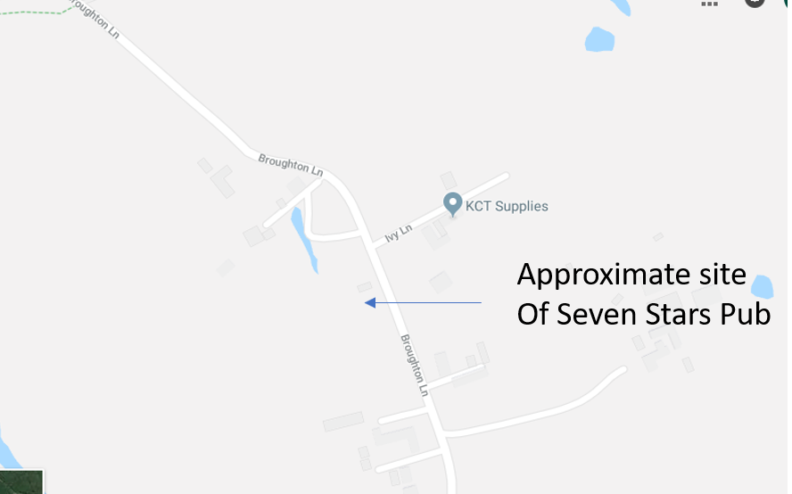

The 1841 census shows the Publican as William King, aged 45, who lived with his wife Ann, also aged 45 and his son George, aged 15 and Mary Peasbut aged 7.
In 1847 the post office directory shows that George is still the Publican, but by the time of the 1851 census, his widow Ann is the licensee, she’s aged 58 and is living with her son George, aged 24. In 1854, George is shown as the Publican. The 1861 census shows Ann as the Publican, but living with her is George, who is aged 34 and a Farmer. Ann continues to appear as Publican in the trade directories of 1864 and 1869.
The 1871 census shows George as the Publican, he is now aged 45 and is living with his wife, Jane (aged 35), she was born in Bierton. They have 4 daughters – Ellen aged 10, Jessie aged 3, Ann aged 1 and Louisa aged 1 month.
The 1881 census again shows George as the publican with his wife Jane and two daughters, Ellen aged 19 and Jessie aged 13.
The 1891 census shows that George is now aged 60 and is a widower. His daughters are still living with him. Ellen is aged 27, Annie is aged 20 and a Dressmaker, Louisa is aged 18 and a Dressmaker, Emma is aged 15, Lily is aged 12, Julia is aged 10. Also living with them is Eli Ship who is a lodger and farm labourer.
The 1901 census shows George, aged 71 with Ellen aged 35, Louisa aged 26, Lily aged 22 and Julia aged 20. Eli Ship is still a lodger at the pub and is now aged 60.
The 1903 Kellys Directory shows the publican as being Edward Bishop, but he doesn’t seem to have as much staying power as George because by 1911 there is a new publican.
The 1911 Kellys Directory shows that the publican is Mrs Mary Stratford, she remains there until sometime between 1915 and 1924 when Herbert Stratford takes over, presumably husband or son of Mary Stratford.
In 1912 the pub was described as “The Seven Stars Inn, at Broughton, about a mile S.E. of the church, is of two storeys, the upper storey partly in the roof. It was built of brick and timber probably in the middle of the 17th century, and has been partly re-faced with modern brick. The roof is thatched. One chimney stack is of old thin bricks. On the ground floor is a large open fireplace and one ceiling has a stop-chamfered beam.” (Source - https://www.british-history.ac.uk/rchme/bucks/vol1/pp47-51)
The Aylesbury Brewery Company owned the pub for a while and transferred the licence for it to the Prince of Wales pub in Broughton in 1927.
We’re not sure when the pub closed, but was turned into two cottages, one of which is known as the Old Seven Stars Cottage.

The Star

Named in the 1881 census. To clarify where other census entries and directory detail comes from, there are two unnamed beer houses in Bierton. The Crown is generally described as Parsons Lane, whilst the Star is always near to the Bell in the census. The 1871 census describes this as tailors Row.
It’s possible that the pub was located somewhere near what is locally known as Star Alley, almost opposite Barnett Way.
In 1854, William Bonham is listed as Tailor and Beer Retailer at the Star. The 1871 census shows William Bonham (60 – Widower & Tailor, born in Bierton. James Bonham his son who ias aged 24 and a Carpenter and Joiner and Annie Bonham, daughter to William and a 19 year old dressmaker.
By 1877 James Quarington is listed in the Kellys Directory as Beer Retailer at the Star. The 1881 census shows James is aged 42 and is listed as a General Labourer from Ellesborough. His wife is Sarah a Beer Shop Keeper aged 37 from Halton.
By 1891 Thomas Pipkin is listed as the Beer Retailer. The 1891 census shows him as Butcher and Publican. He was born in Hartwell. His wife is Kate Pipkin aged 33. By 1895, Thomas has died as Kate is listed as the Retailer. By 1899 it looks like Kate remarried as she’s now Mrs Kate West.
The 1901 census shows Levi West is the 29 year old Inn Keeper, he was born in Tring. Kate is his wife aged 42 from Rowsham.
Aylesbury Brewing Company bought the pub in 1928 for £600, they state it was located at 163 Aylesbury Road. The pub closed in 1966.

