The Gables is located in Burcott Lane and was built c1900

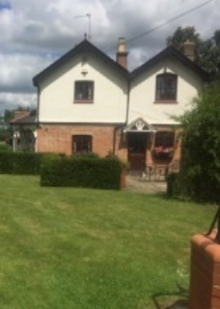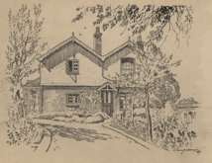

Above are a sketch of the house and a photo of the current house (note the edge of well on the far right of the photo)

One famous resident who lived at the Gables was Mary Amelia St. Clair Sinclair. She was born on 24th August 1863 in Cheshire. She became a popular author, philosopher and suffragette. She spent the last 14 years of her life at the Gables in Bierton. She used the pen name May Sinclair for her books.

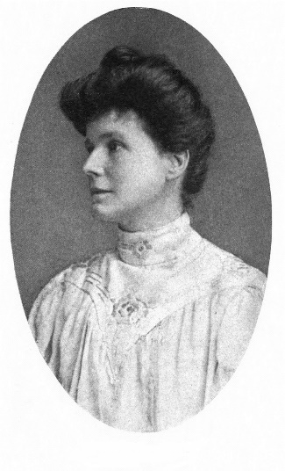

She published 24 novels, 2 novellas, 5 collections of short stories, 2 of verse, 2 of philosophy and many essays. She created the phrase ‘stream of consciousness’ and played an important role in pschology in literature.

Due to struggling finances, her parents seperated and May lived with her Mother, Amelia. May was educated at Cheltenham’s Ladies College and the Headteacher, Dorothea Beale became her mentor. Dorothea offered May a role as Lecturer at the College, but due to her Mother’s failing health, May was unable to accept.

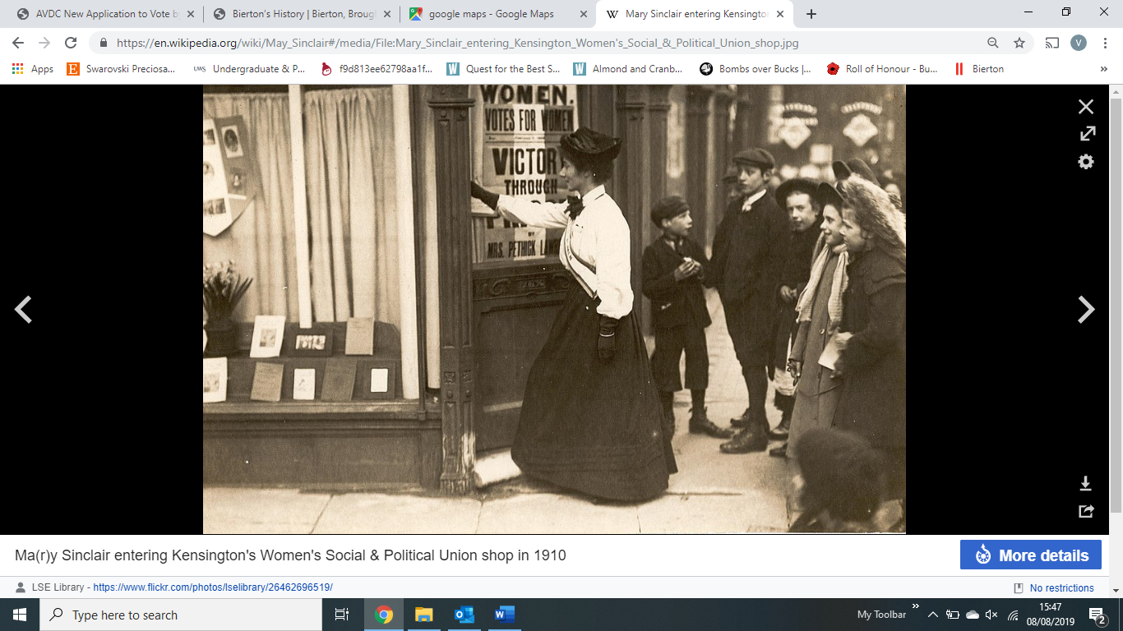Amelia died in 1901, releasing May from caring duties and enabling her to be in control of her life for the first time. At this time May’s writing was very popular. She campaigned for women’s suffrage, drove an ambulance in Belgium during WW1 and was a founding member of the London Medio-Pyschological Clinc, the first facility in England to include phschoanalysis amongst a range of treatments for mental health illnesses.

Due to her successful books, May met a host of celebrities including Thomas Hardy, Mark Twain, TS Elliott, HG Wells and Sylvia Pankhurst.

At the height of her career in the early 1920’s, May developed Parkinson’s disease, by 1930 it had progressed and forced her into seclusion. In 1930 May and Florence Bartop, her nurse/companion moved to Tingewick, then in 1932 they moved to the Gables in Bierton. The Gables was chosen for its ‘seclusion, shade, ample garden and long side porch trellised with purple clematis which in Spring and Summer brought the sky right down to earth as a curtain of flowers’. May lived here with Florence until her death on 14 November 1946.

Many of her papers are stored at the University of Pennsylvania. They were discovered by Theophilus Boll at the Gables in Bierton in 1959, during research into a biography about May Sinclair. When Theophilus visited the Gables to find out more about May, Florence took him to an outbuilding which had been a stable and a garage and showed him boxes and trunks which contained May’s papers. Theophilus went on to write a book ‘Miss May Sinclair, Novelist’ published in 1972.

At some point after May and Florence’s departure, the Gables became a convalescent home. Mike Griffin’s Mother lived there for a while and also passed away in the house.

More recently, when the garden was being landscaped, a well was discovered, the edge of which can be seen in the photo at the top of this document.

Thanks to the current homeowner for sharing the drawing, photo and history of the Gables.

Other photos of The Gables have been shared, showing families with the surname of Bush, Gurney and Parkins living there. Here are some photos that have kindly been shared by a local lady doing some family history research.

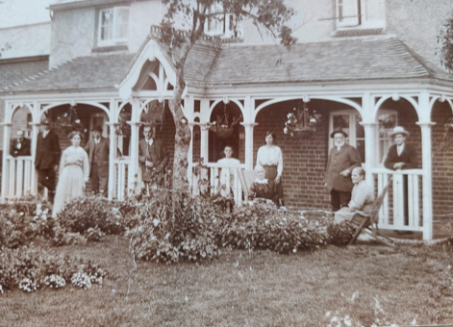

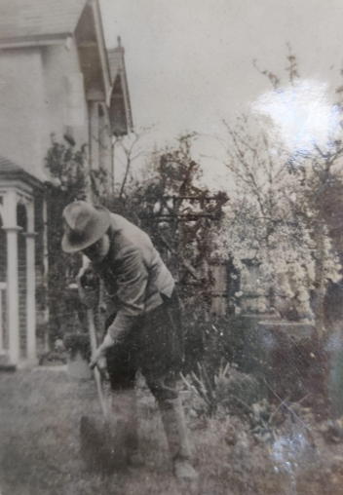

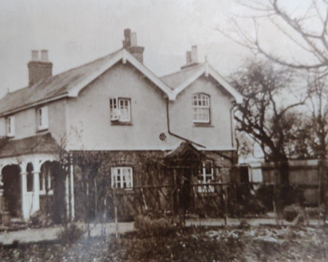

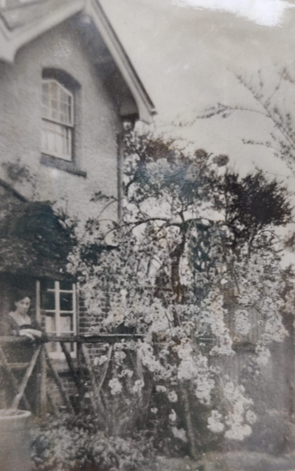

Sources:

<https://maysinclairsociety.com/biography/>

<https://en.wikipedia.org/wiki/May_Sinclair>

<http://dla.library.upenn.edu/dla/ead/ead.html?q=Sinclair&id=EAD_upenn_rbml_MsColl184&>

<https://books.google.co.uk/books?id=xkT2o5Q7hOsC&pg=PA152&lpg=PA152&dq=the+gables+burcott+lane+bierton&source=bl&ots=4qeck7rusO&sig=ACfU3U3uOlwQ4RU1UGHMaQXDxHmQ1rFOQQ&hl=en&sa=X&ved=2ahUKEwiS5qSrx_PjAhUATxUIHdrqB-UQ6AEwBnoECAkQAQ#v=onepage&q=the%20gables%20burcott%20lane%20bierton&f=false>