Great Lane Circular walk via Hulcott (Late Spring Buttercup walk)

Distance: c3 miles.
Terrain: Mostly good
Interesting points: Ponds, long-stile, householder gardens.
Difficulties: Footbridges, stiles and gates, high grass/nettles in Summer.
Not suitable for: Buggies, bikes, wheelchairs, scooters or people in deep-see diving equipment
Footpaths used: BwB 4/1. BwB 4/3. BwB 4/4. Hul 1/1. BwB 4a/1.

- Setting off from the A418, go up Great Lane for about 100 metres, until you see a footpath sign on your right. Take this path and you will find the allotments.
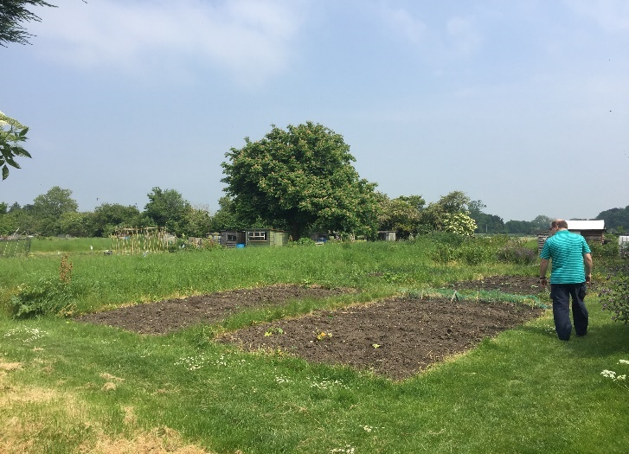
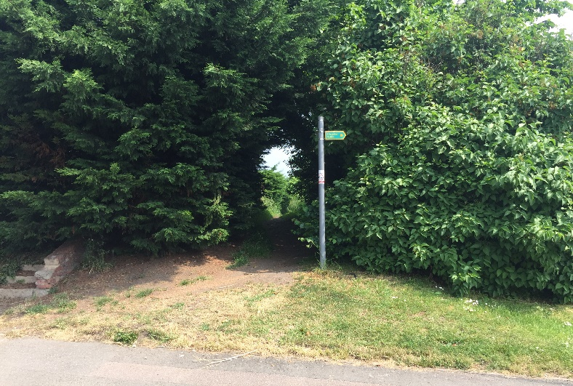
- Follow the path, to a stile, which you cross.
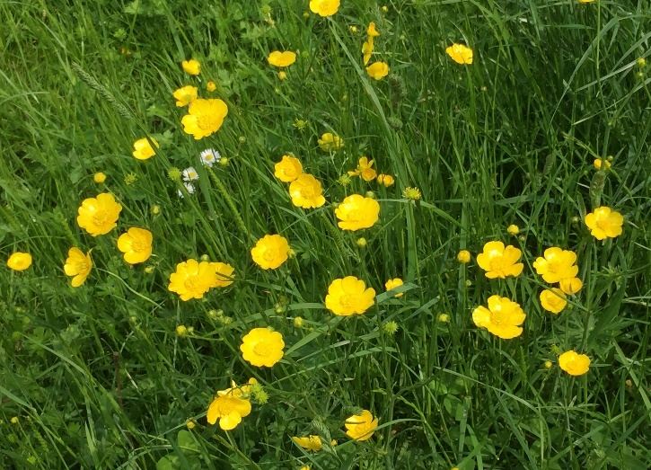
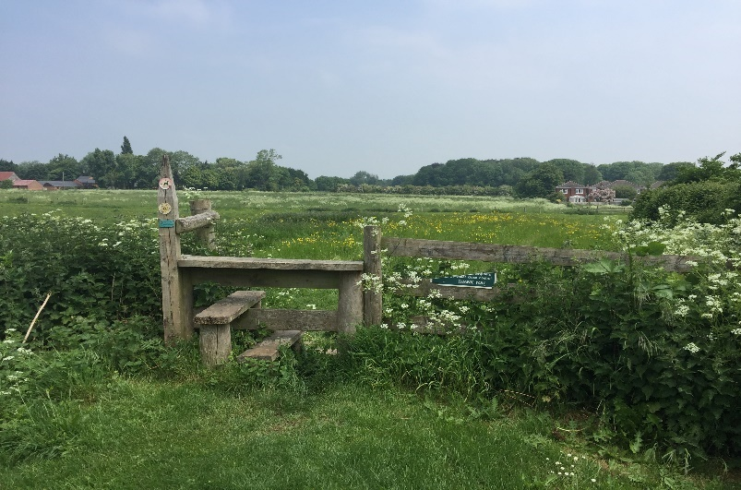

- Head straight ahead and slightly right across the field and you’ll arrive at a gate.
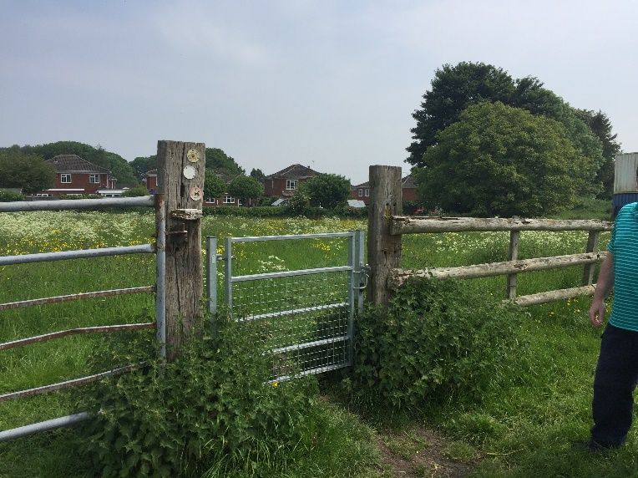
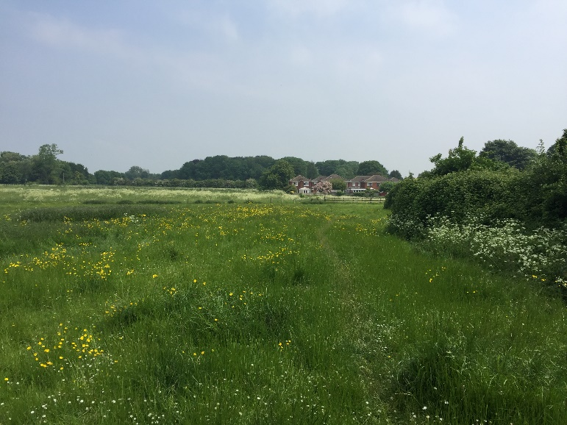

- Go through the gate and head diagonally to the right and you’ll exit the field into Barnett Way. Walk straight ahead, crossing Barnett Way and you’ll see a footpath sign next to a wooden fence. Follow the footpath.

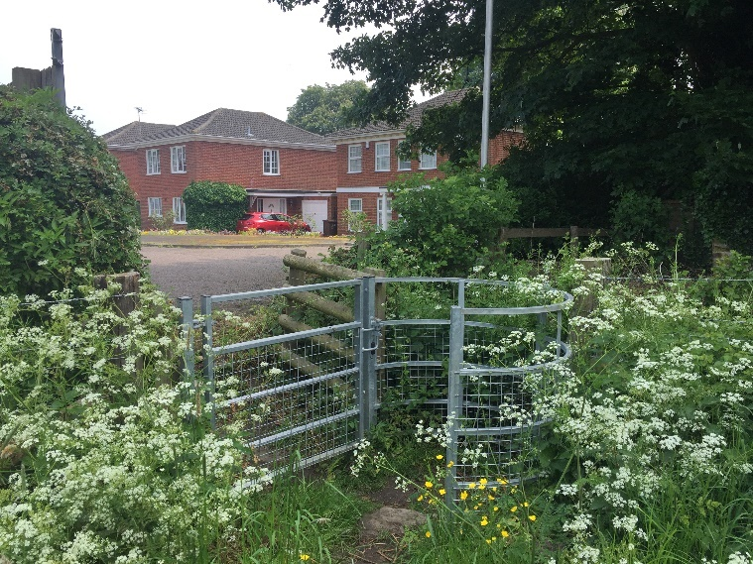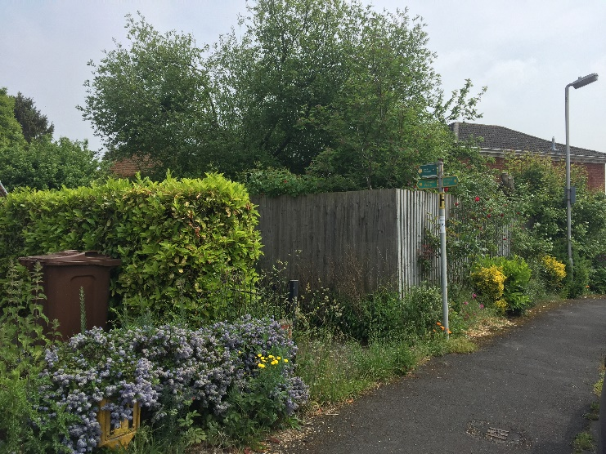

- Very quickly, you’ll come to a stile with a gate next to it. Go through and walk straight ahead. You are following the right of way through a householder’s garden, so please stick to the path.
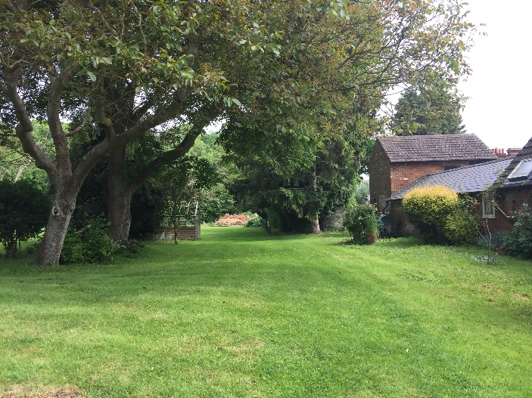
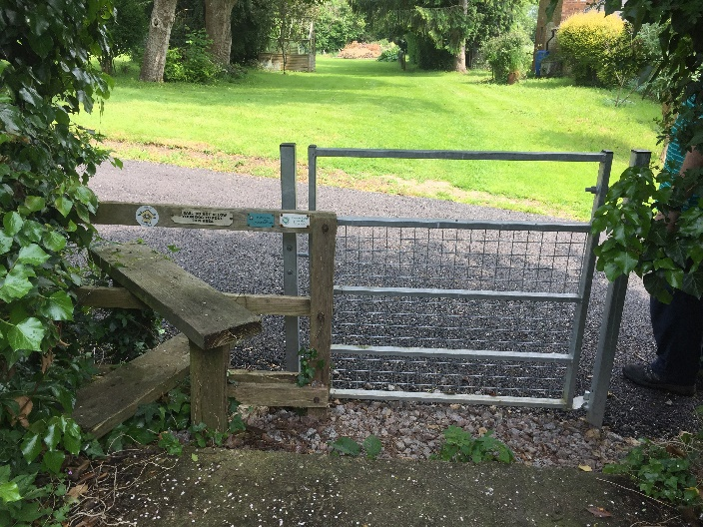

- You will soon come to a metal fence, which you need to keep to your left. You will then come to a stile.

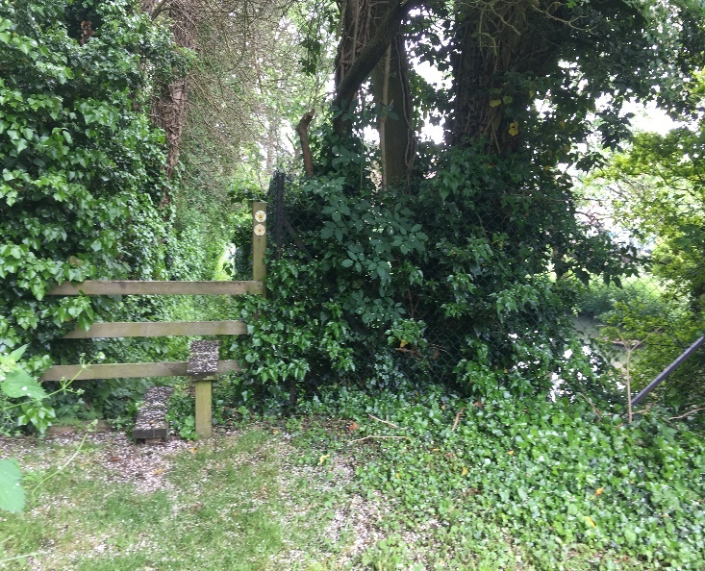
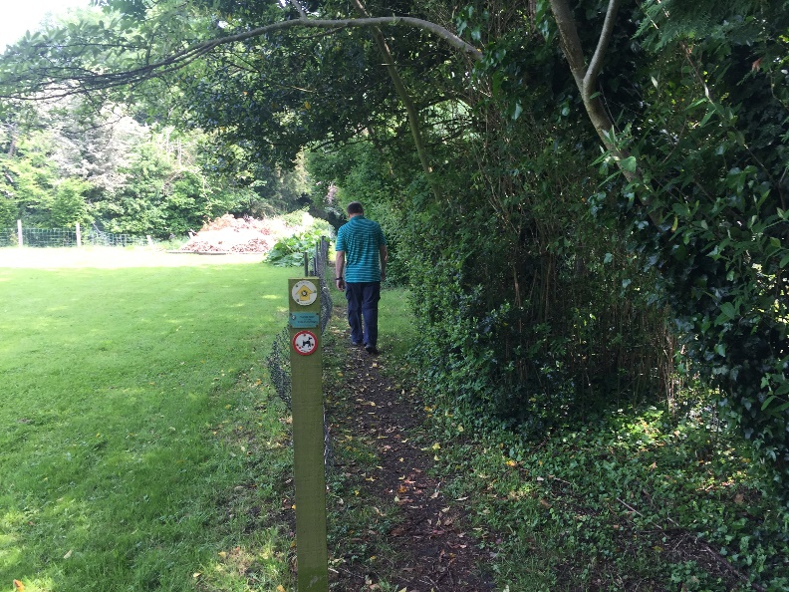

- You will now walk along a narrow path with pond on both sides of you. There are usually ducks in the pond on the right. The ponds on the left are private fishing ponds.
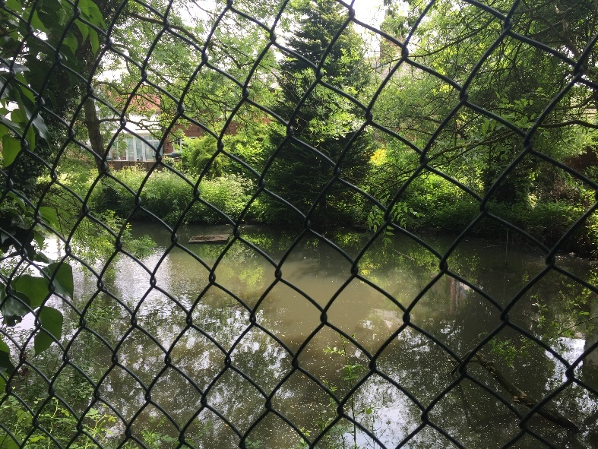
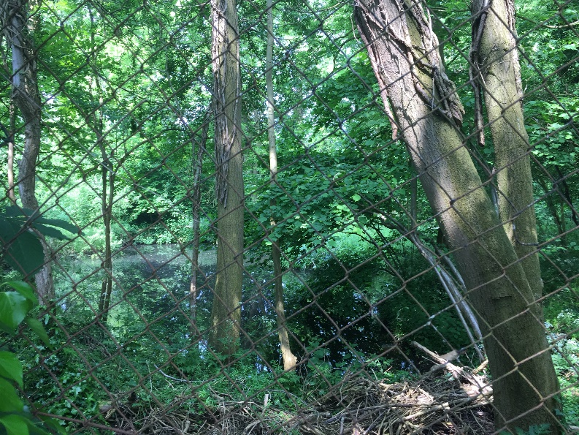
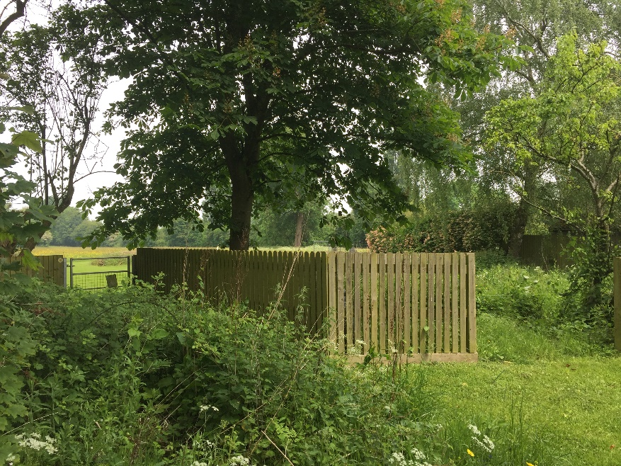
- This is a lovely shady part of the walk on a hot Summers day. At the end this part of the walk you’ll enter Brick Kiln Lane. If you’ve had enough, you can walk down the lane and join the A418. If not, carry on straight ahead over the stile.

There are another 2 stiles in a short distance, before you come to an open field. Cross the field and you’ll enter the back of a householder’s garden.

There are two footpaths, take the left hand one. (You’ll be returning via the right-hand path).

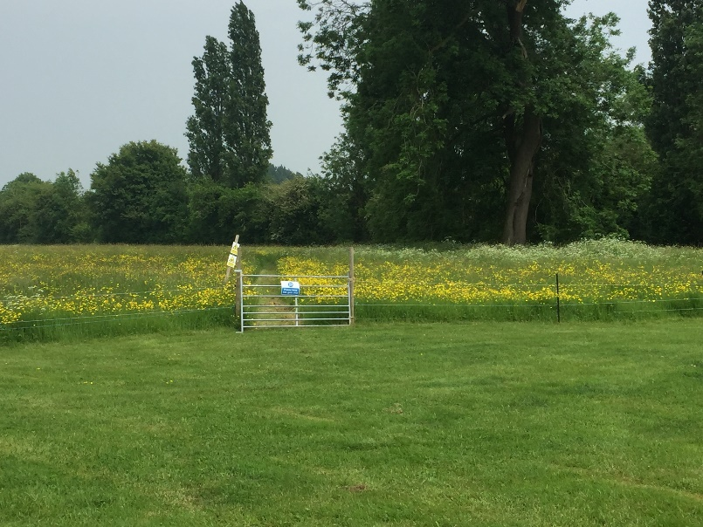

- Cross the field and go through a gate.

Full marks to this landowner who has cut a wide tidy path through the greenery, which makes it easy to find your way.

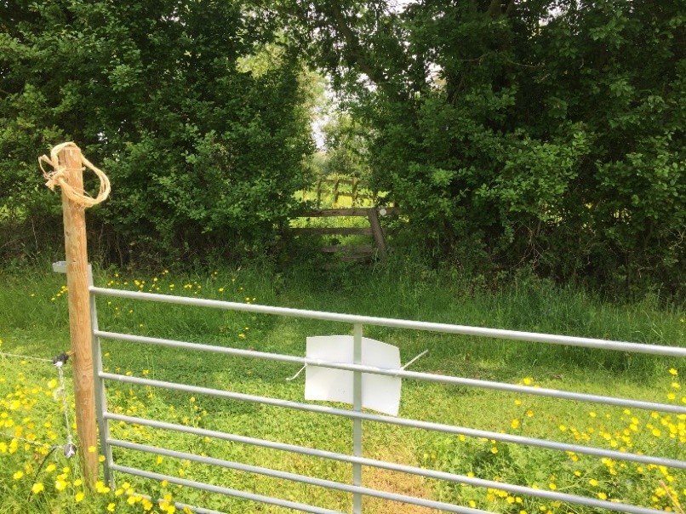
- Going through the second metal gate, you’ll see a stile right opposite you. Go over this and you’ll go through a track between two fields. Go over another stile.

- Cross the field to a metal gate and short wooden bridge (bottom left picture). You have nearly returned to civilisation. Follow the path (bottom right) and you’ll cross a stile which is on Rowsham Road.

If you’ve had a long enough walk, turn right and join the A418, turn right and you’ll return towards Great Lane. If you want to continue then…

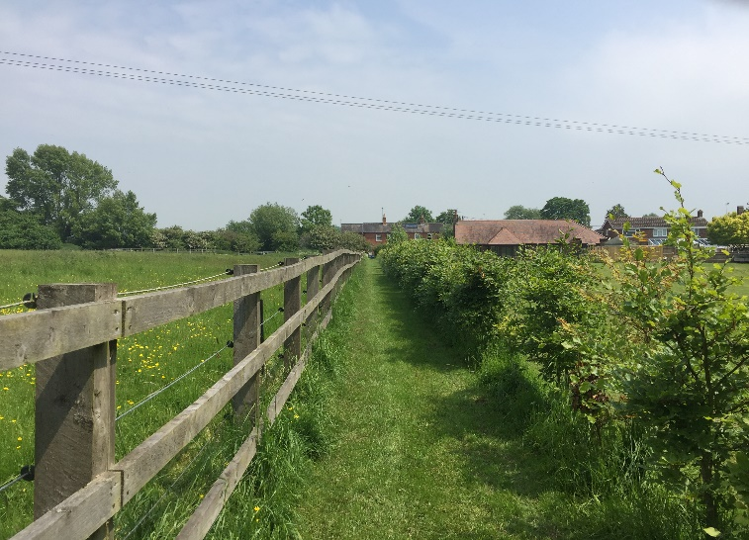
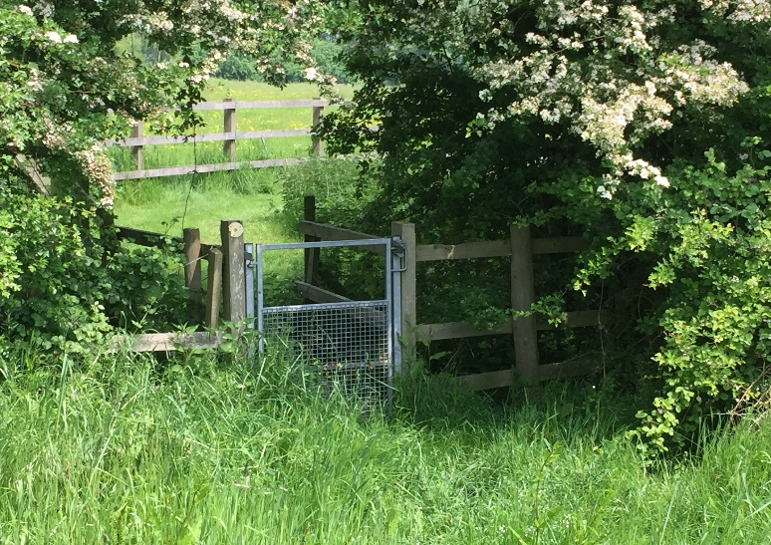

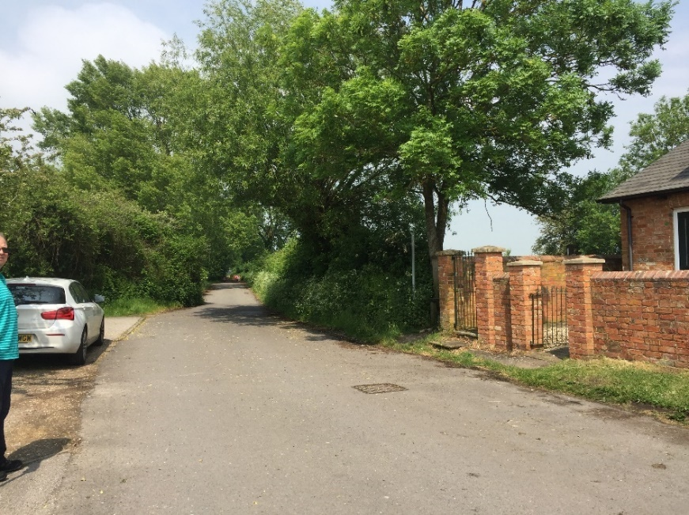
- Cross Rowsham Road and you’ll see a footpath sign just to your left, next to the last house facing you.

- Cross the stile and follow the path between the two fields. You’ll see a small pond on your right.

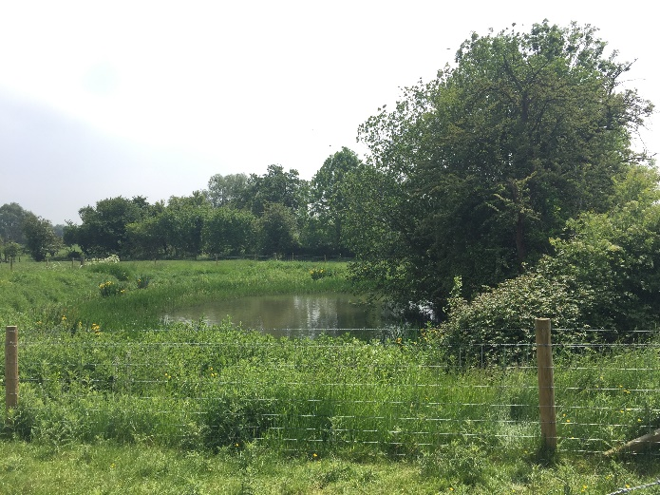
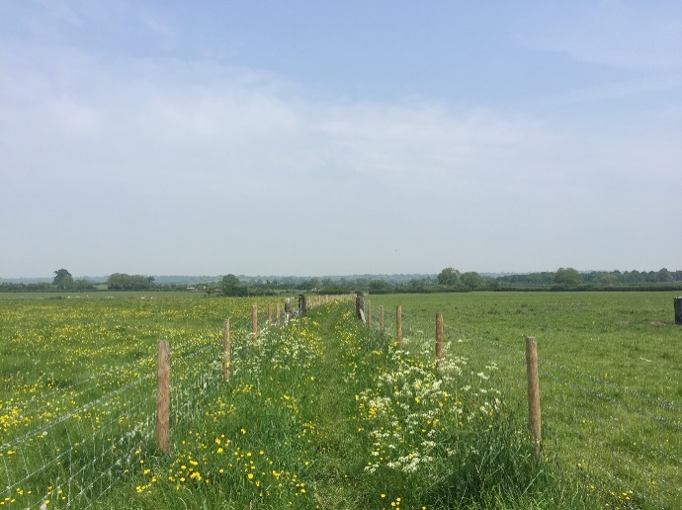

- Continue through the path and you’ll come to a long stile. I’ve not seen many stiles this style but it’s designed to help you cross a small brook.

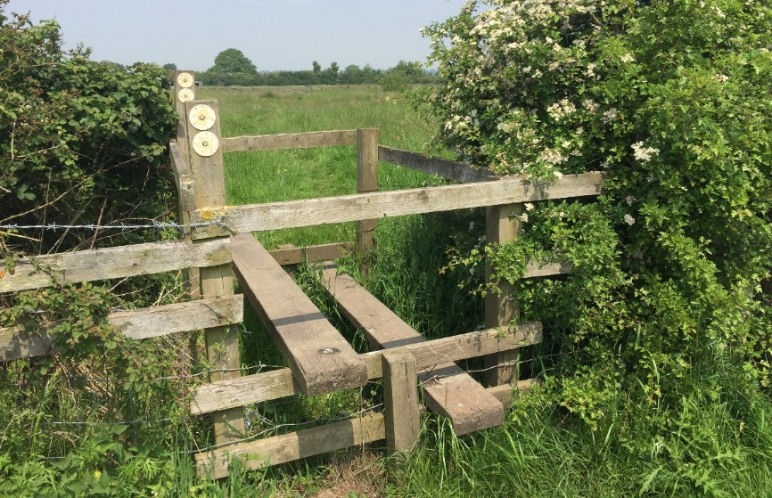

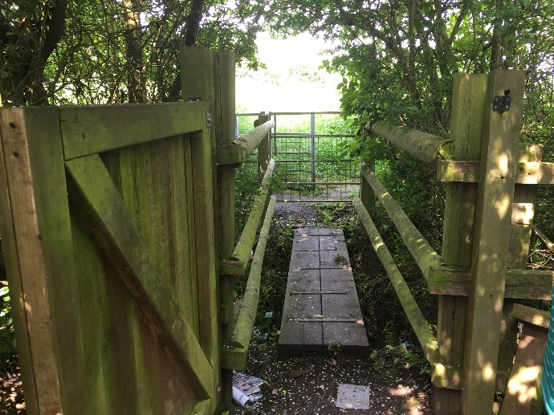
- Make your way across the field, crossing a small wooden bridge and through a metal gate. In the next field there are two metal gates, take the left-hand one (you’ll return via the right-hand one). Continue and you’ll come to a gate, bridge, kissing gate combination.

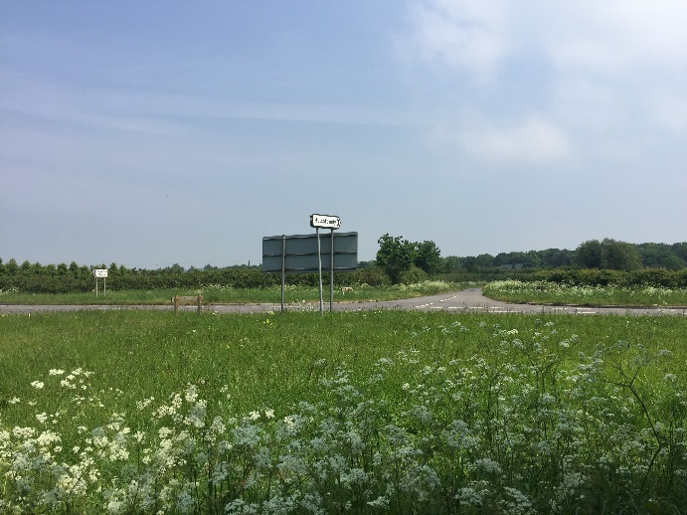
- Once through the gate you are on the A418/Hulcott/ Rowsham Road junction. Cross the road, taking care as the traffic can be quite fast. Start walking along the Hulcott Road towards the centre of Hulcott.

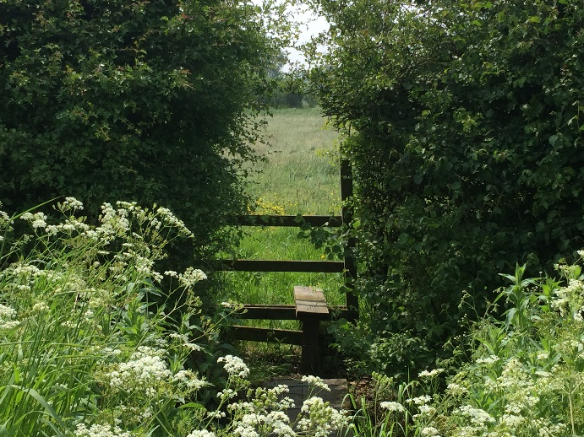
- Look out for a footpath sign and stile on your right. It’s just before the landscaping company which is on your left.

- Cross the field, taking a slightly right-hand path. You’ll cross a brook with a wooden footbridge (below right). Keep the group of trees on your left.
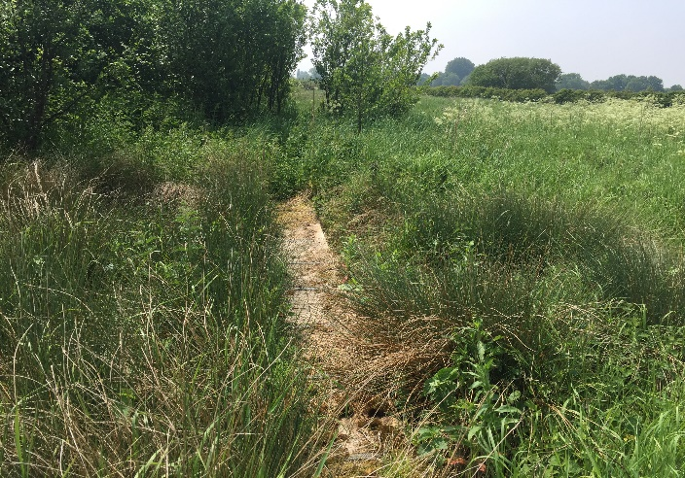
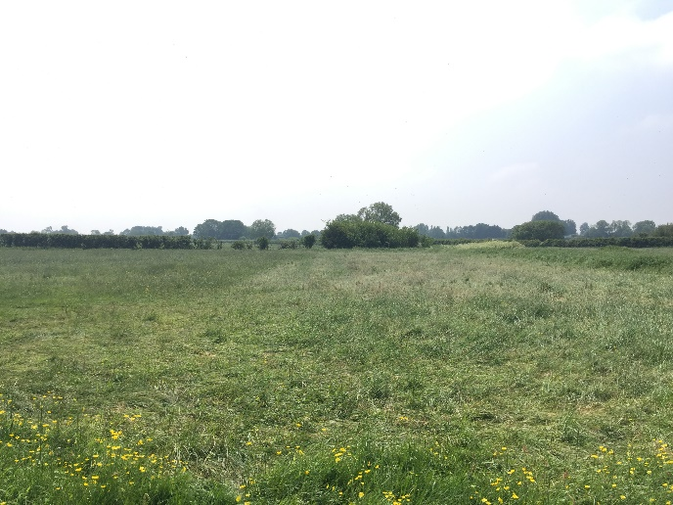

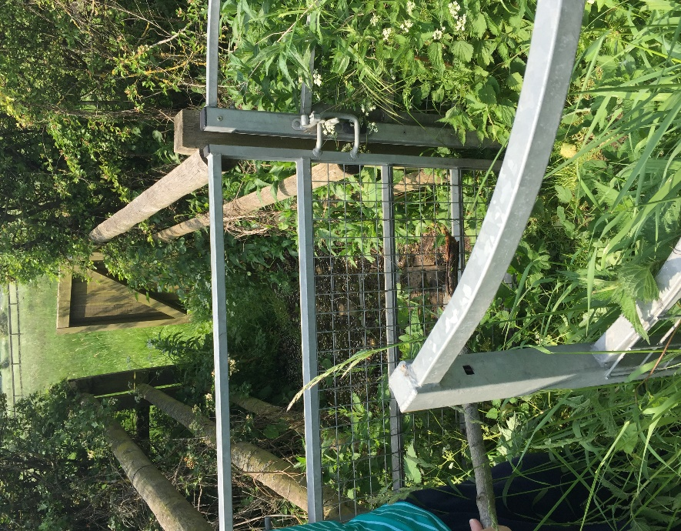

- Near the end of the field and close to the hedges which mark the edge of the field with the A418, you’ll cross a stile, turn immediately right and cross another stile. You will now need to cross the A418 again. Directly opposite you is a kissing gate, wooden footbridge and gate combination (pictured here).

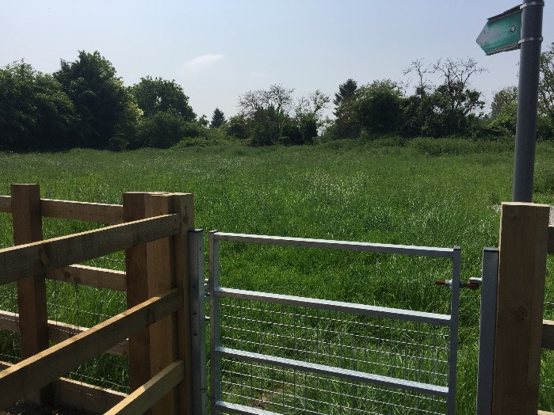
- Cross the field, returning the way you came to Rowsham Road.

You can now either walk down Rowsham Road, turn right on to the A418 or continue. The return route is slightly different in places and I think an interesting walk.

To continue, come to Rowsham Road, turn left and head towards the A418, take Grove Court (turning on your right). At the end of this road, you’ll see a footpath sign and metal gate. Head diagonally left.

- Cross a stile at the end of the field and continue straight. You will now be going through householder’s gardens and a horse dressage area, so please stick to the path.

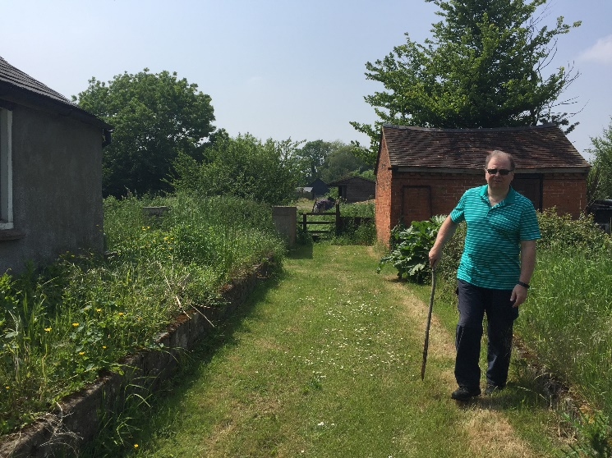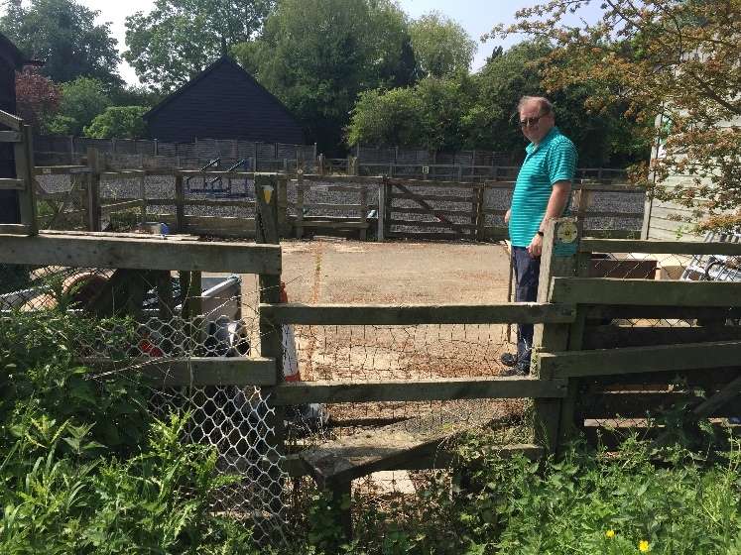

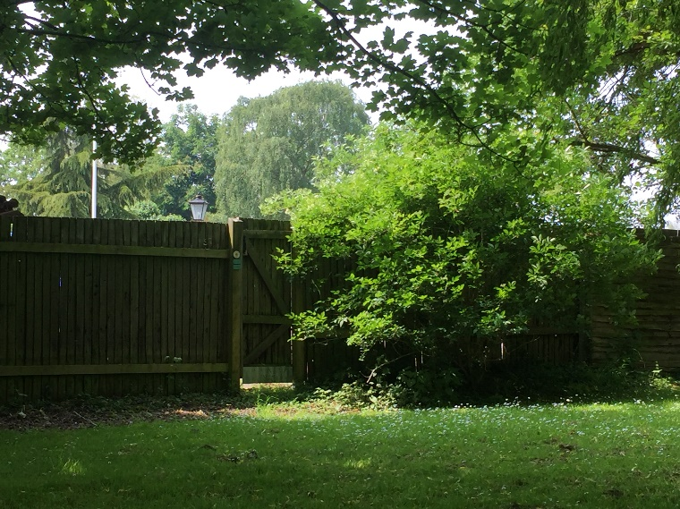
- Continue through gates and over stiles. You will then come to a garden with a wooden gate.

- Head diagonally right and go through a wooden gate. Continue straight and you’ll enter the garden where you took the left-hand footpath (Step 8). Continue back the way you came until you reach Great Lane.

