The Red Lion, Bierton to The Five Elms, Weedon (option of shorter circular walk)

Distance: c3 miles (each way)
Terrain: Mostly good, some pitted and uneven ground around Grendon Hill Farm.
Interesting points: Fairy door, views of Weedon and Turbine, long wooden footbridge, pub at either end of the walk.
Difficulties: Narrow footbridge, stiles and gates, high grass/nettles in Summer.
Not suitable for: Buggies, bikes, wheelchairs, scooters or elephants
Footpaths used: BwB 3/4

- Setting off from the Red Lion Pub in Bierton, leave the pub and turn left.

- Turn left into Great Lane and walk along the road. The road inclines slightly and eventually becomes an unmade road. (Photo below shows start of unmade road at the point where the houses end)

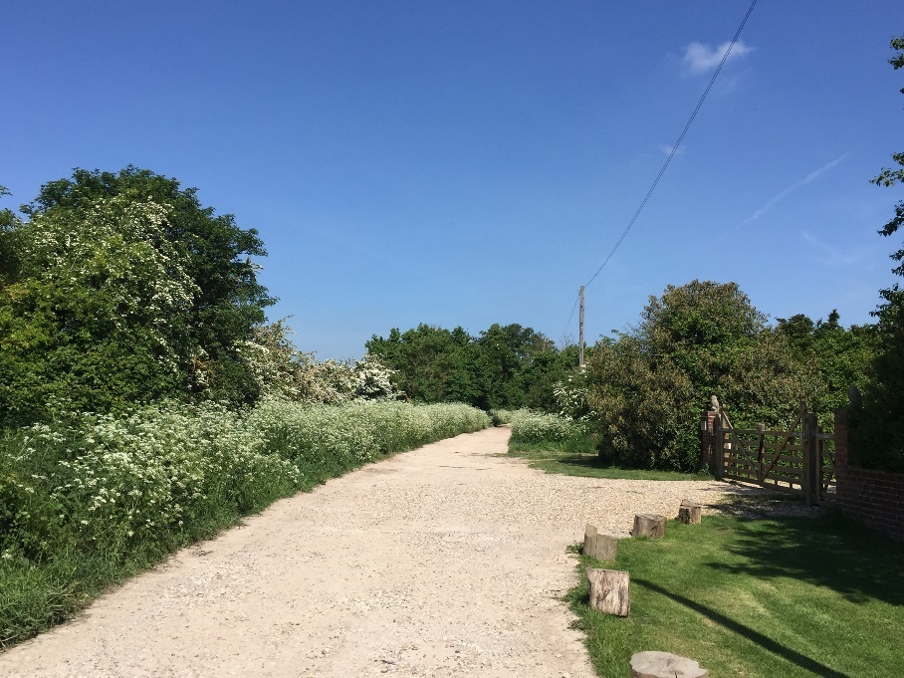
- Keep an eye out for a large tree on your left which has a lovely fairy door and high treehouse. Don’t try to climb to the treehouse it’s very high up and there isn’t an easy way to reach it.
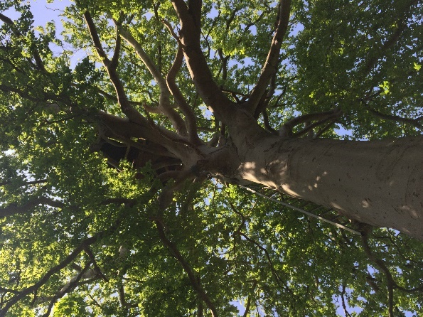
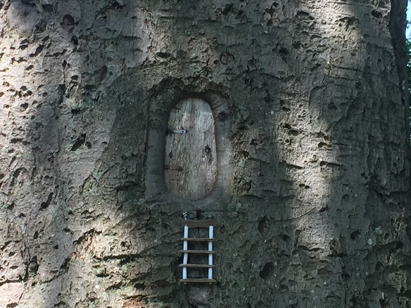
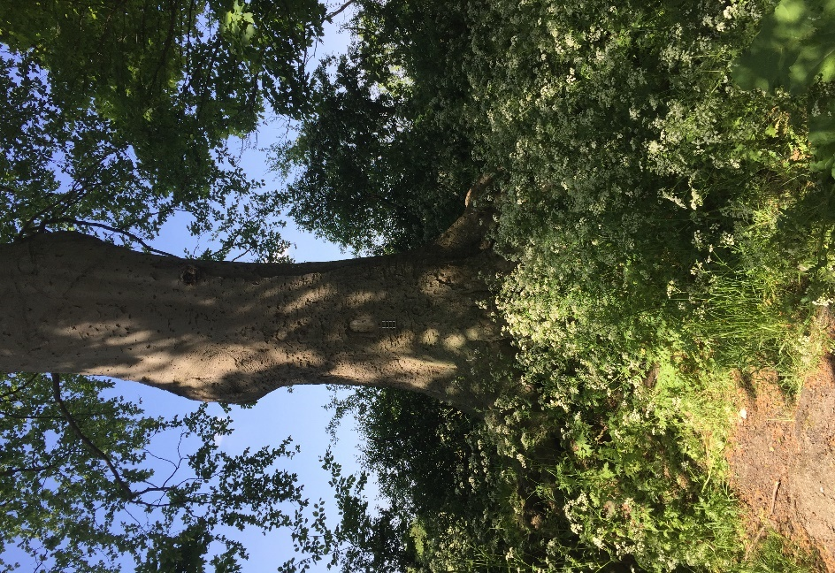
The fairy door tree. Look up and you see the very high treehouse.

- The road runs level for a while, before going downhill towards Grendon Farm Cottages.

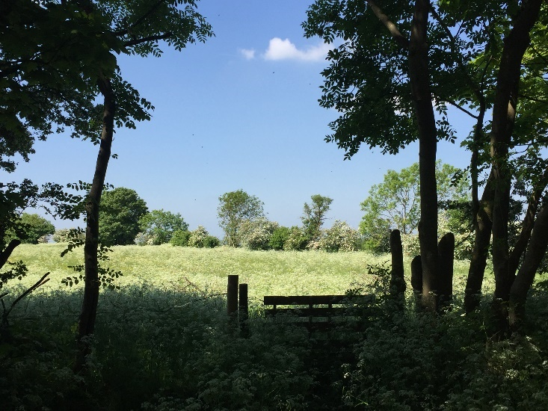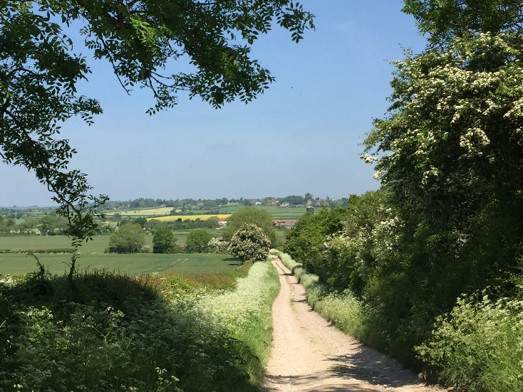

By the cottages, you can take a circular route back to the Red Lion or The Bell in Bierton, by taking the footpath on the right, through the hedge opposite the cottages, go ahead for c300 metres and you’ll see a metal gate and a kissing gate on your right. Go through these, climb the hill, through another field and you’ll find your way back to the main Bierton Road. There are stiles along this route. Be aware that there may be cows with calves in the top field.

Or you can continue towards Weedon. Immediately after the Farm Cottages you have a choice of routes which will end in the same place. Either

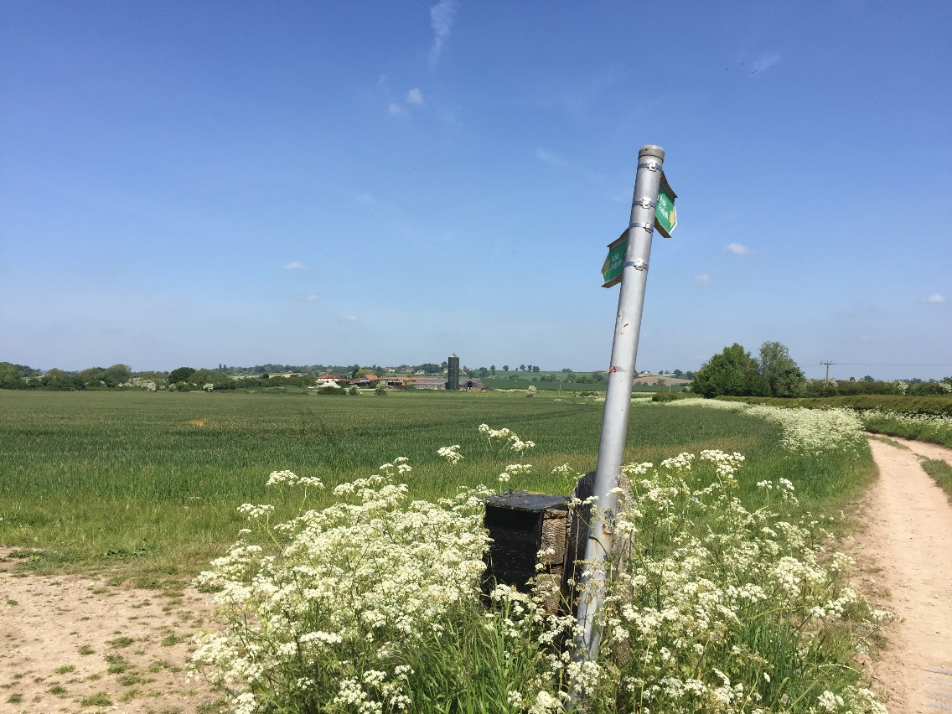

- take a route across the field to your left, which will take you to two gates with a narrow bridge between, then on to a stile and a nettle filled field, then a kissing gate. You will finish near the end of the farm.
Or
- continue along the road which bends slightly and you will walk through the farmyard, past the farm house and through a large metal gate.

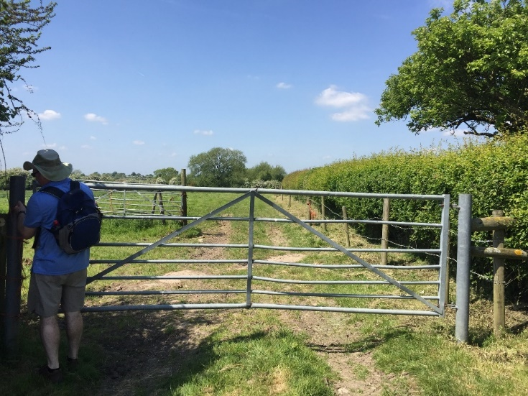

- Regardless of whether you took route a or b you will now be at the end of the farm.
The photo on the right shows the gate you go through at the end of the farm. If you crossed the field, you will arrive the other side of the gate.

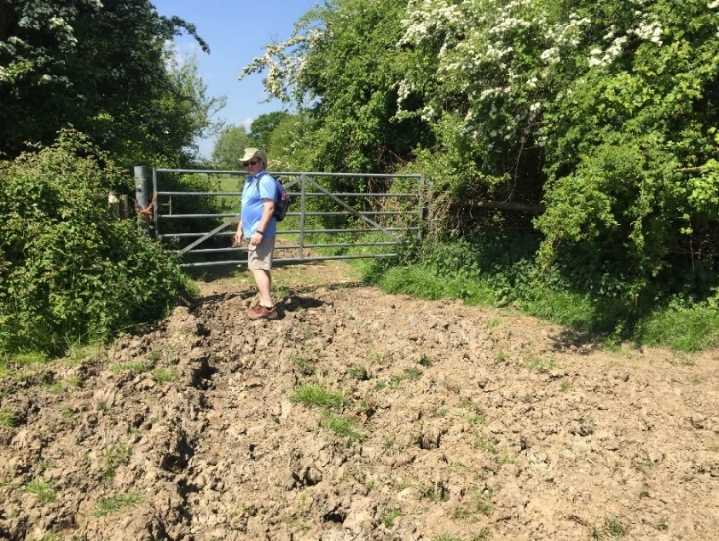
- Continue, heading slightly downwards, going through a large metal gate – be careful as the ground is very rutted here.

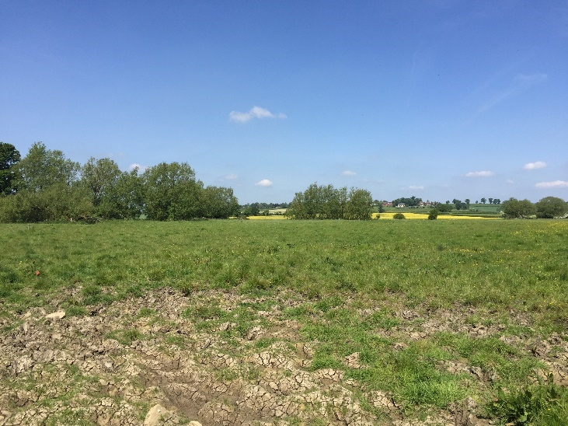
- You will see a pond on your left-hand side and a small stream on your right. Now make for a clump of trees ahead and to the right.

- You will find a narrow footbridge with a stile on each end. The bridge goes over a stream, which is the River Thame, which has almost made an oxbow lake.

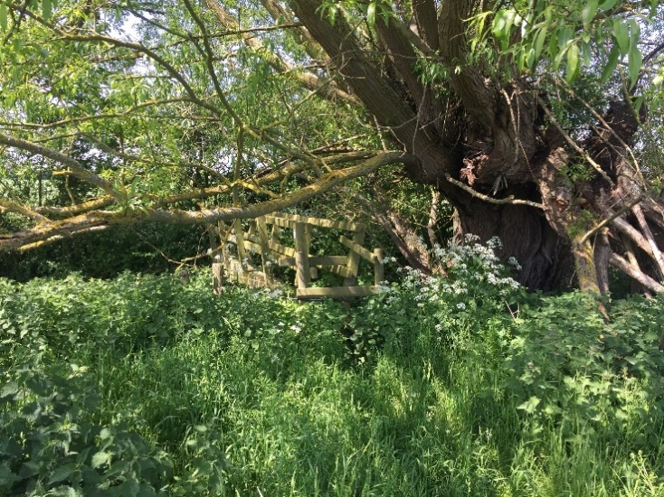
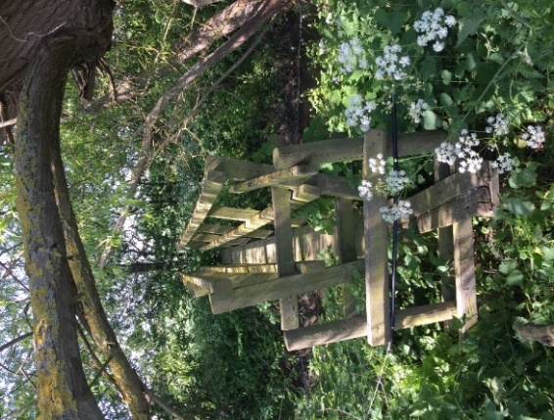

- Once over the bridge, you are beyond the boundaries of Bierton with Broughton. Continue through some fields until you reach Weedon. As you enter Weedon walk along East End to the main road where you turn left and walk to the pub, which has a small outdoor seating area and serves food.

