Three pub circular walk

Distance: Who cares, c2miles
Terrain: Mostly good.
Interesting points: The Red Lion, The Bell and the Doghouse.
Difficulties: Narrow footbridge, stiles and gates, high grass/nettles in Summer, finding your way home.
Not suitable for: Buggies, bikes, wheelchairs, scooters or people who are allergic to pubs.

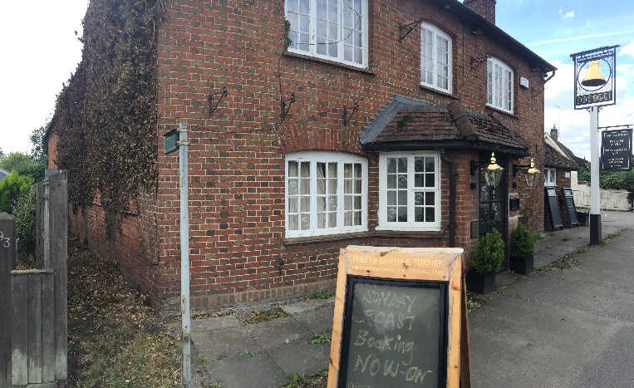
- Starting at the Bell pub. Once you’ve had some refreshment and/or nourishment for your walk (they do a lovely Thai meal and many other dishes). Leave the pub and turn right, immediately after the Bell you will see a footpath on your right.

- Walk along the path and over a stile. Then walk diagonally across the field, to a stile/bridge combo.

- Then walk diagonally across the next, smaller field, to another stile. Then head towards the right-hand corner of the final field. Here you will cross 2 stiles and be on Burcott Lane. You will pop out just near the Sports Centre.

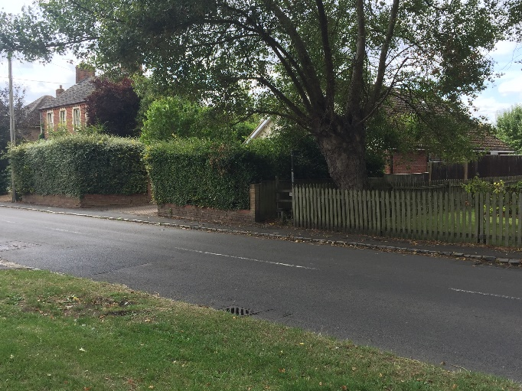

- Cross the road carefully and go over the stile. You will be able to practice hurdling as you’ll be crossing 3 stiles in a fairly short time.

- When you see a footpath from the right, joining yours, turn left onto another footpath.

- Follow this and you’ll come out on Burcott Lane, near the old dairy (crossing another stile/bridge and stile on route).

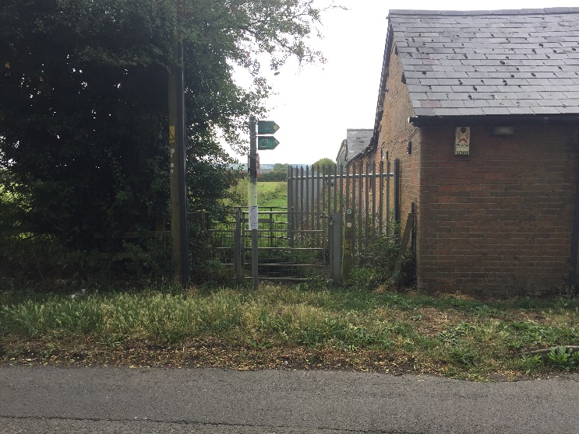

- Turn right, cross the road and take the foothpath just to the left of the old dairy.

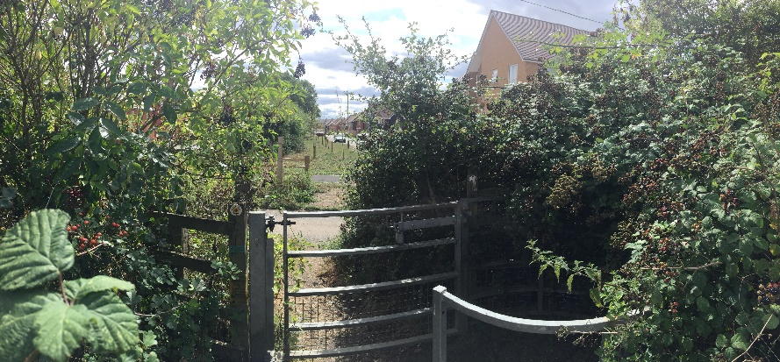
- Continue straight, at the end of the metal fencing on your right you will see a kissing gate and footpath sign, ignore this as its extremely overgrown at present.

- Continue straight and you’ll reach a metal gate and will see Kingsbrook houses.

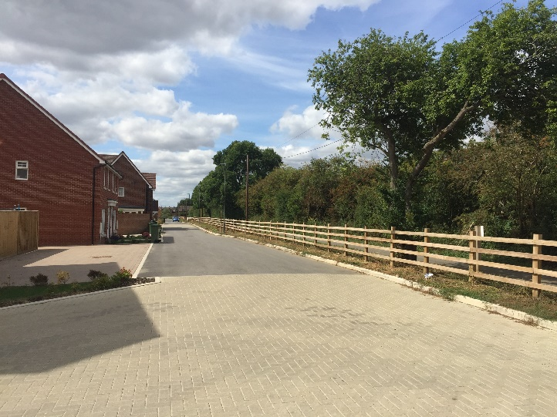
- Go through the gate and turn right, walk until you reach Burcott Lane, turn right and you’ll find the Doghouse pub. By now, you’ll be thirsty and possibly hungry again, so stop and enjoy the hospitality. If you’re here for Sunday lunch you’re in for a treat.

- Feeling fully refreshed, leave the pub and retrace your steps back to Burcott Lane and the old dairy.
- Cross the road and take the new footpath on your left which runs alongside the road to the corner of Burcott Lane (you will pass the bottom of muddy lane foothpath – but carry on).

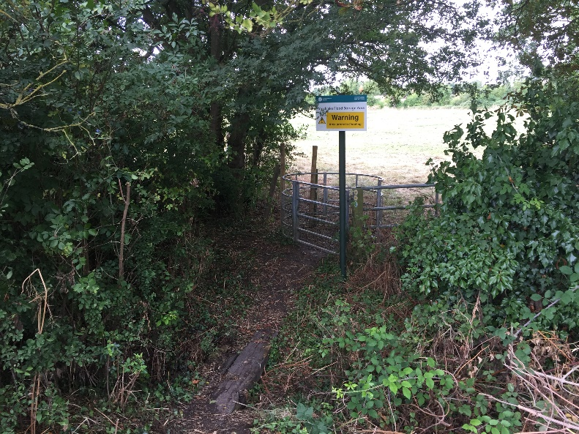
- On the corner is a signpost to the footpath which is reached by a little wooden bridge and metal kissing gate.

- Go through the gate and walk straight ahead, you’ll go through another gate and into another field.

- Keep going straight, being careful of parts which can be a bit boggy in Winter. Walk up the slight incline (with the back of Bierton school on your right).
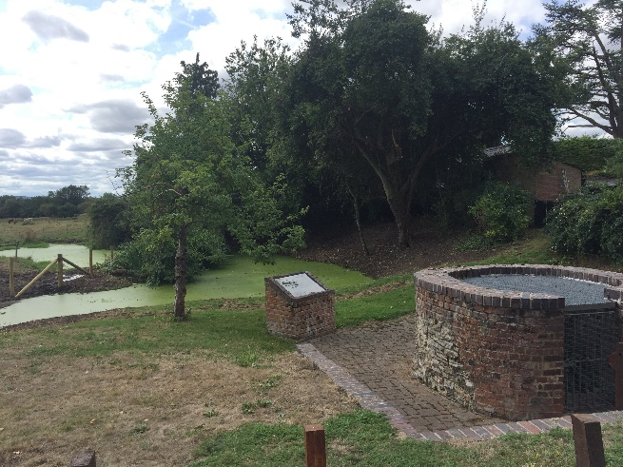

- Go through a kissing gate and here you’ll find St Osyths well and a plaque telling you more about her.

- Continue straight to the main A418. Turn right and you’ll see the Red Lion pub opposite. Pop on in for some nourishment, if you’re lucky their pizza ovens will be on.

- Feeling full of joy and with a spring or stagger in your step, leave the Red Lion pub, turn left and continue along the main A418 until you return to the Bell pub.

- If you’re feeling marvellous at this stage, do it all again or try it backwards.

