William Hill Drive circular walk

Distance: c1mile
Terrain: Mostly good.
Interesting points: Pretty views of St James Church
Difficulties: Narrow footbridge, stiles and gates.
Not suitable for: Buggies, bikes, wheelchairs, scooters or Daleks.

Start/End point

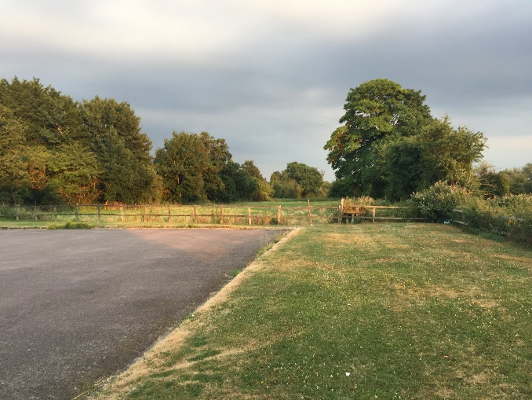
- Setting off from the car park in William Hill Drive. Go through the dodgy stile/gate at the bottom of the car park.

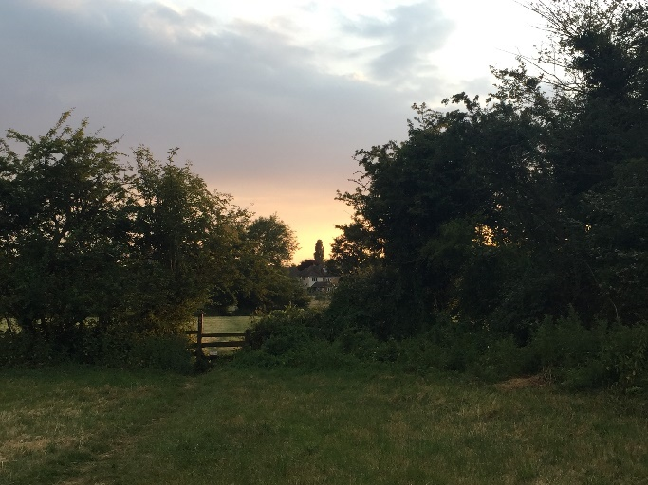

- Continue going straight and you’ll enter a second field. Turn right. Go over one stile. (see picture on the left).

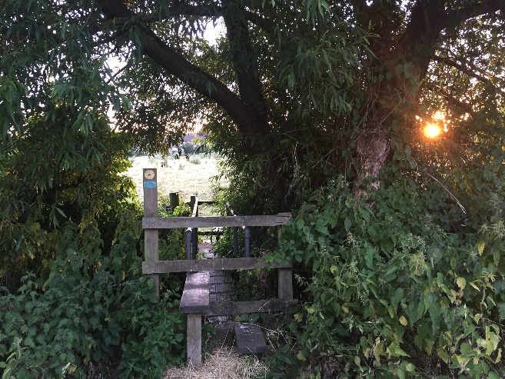

- Continue walking straight and you’ll come to a stile, bridge, stile combination.

- Walk straight ahead and you’ll go through another stile and into Cowley Close.

- Keep going straight to the entrance to Cowley Close, cross the road and walk a few metres up the road.

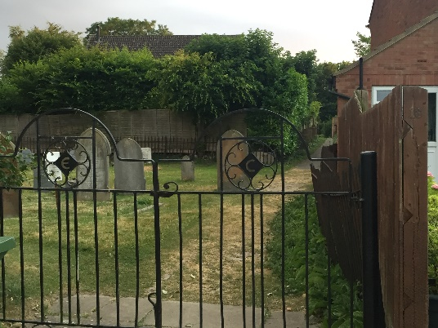
- On your left is the entrance to the Churchyard, go through the gates (closing them after you) and follow the path, which turns right after a few metres. You’ll see a lovely view of St James Church. You can either walk to the left or the right of the church and you’ll come out on the main A418 just opposite the Red Lion Pub.

- Well, you deserve a nice drink or a bite to eat, so pop in and rest your feet a while. When you’re ready to continue, head towards Wing along the main road, cross at the crossing near Jubilee Hall, so that you are on the side opposite Jubilee Hall. Continue walking the same direction and you’ll come to a footpath sign on your right. The footpath is 4 houses back from Old Forge Close (next to a pretty brown bricked cottage with paved driveway).

- Walk along the path, cross the stile and you’ll shortly return to William Hill Drive.

